Carbon Reduction Plan
Supplier name: The Newcastle upon Tyne Hospitals NHS Foundation Trust
Publication date: 25 September 2026

Commitment to achieving Net Zero

Newcastle Hospitals was the first healthcare organisation in the world to declare a climate emergency and acknowledge the associated risk to patient health. In 2021, we were the first healthcare organisation to become a signatory to the United Nations Framework Convention on Climate Change (UNFCC) Race to Zero.
In 2020, we published a 5-year Climate Emergency Strategy with a Net Zero target of 2030 for the emissions we control. This year we reviewed this target with our Board, in developing our next five year plan, and acknowledged that we will be unable to meet this target within current operational, financial and system constraints. Our new target is to reduce our controllable carbon footprint by 50%, from our baseline, over the next five years.

This year we have embedded care for the environment in the Newcastle Hospitals strategy: Caring, improving and learning together (2026-2031). We consider care for the environment as one of our values.

Our revised vision and goals in respect of the climate emergency are within our Climate Emergency Plan for 2026-2031. Our Climate Emergency Plan will deliver benefits for patients and local communities, save money that can be used for frontline care, and improve our environmental performance:

Our Vision
Delivering Sustainable Healthcare in Newcastle (Shine) for People and Planet.

Our Goals
To achieve our vision we have set three long-term goals:

1. Zero Carbon Care
• By 2031 our Carbon Footprint will be reduced by half
• By 2040 our Carbon Footprint Plus will be net zero
2. Clean Air
• By 2031 the vehicles we own will generate ultra-low levels of air pollution
• By 2040 all travel to our sites will be active or sustainable, generating lower
levels of air pollution
3. Zero Waste
• By 2031 we will reduce the amount of waste we dispose of by 10%
• By 2040 all our waste will become a resource within a circular economy

Baseline Emissions Footprint
Baseline emissions are a record of the greenhouse gases that have been produced in the past. Baseline emissions are the reference point against which emissions reduction can be measured. Under the Greenhouse Gas (GHG) Protocol, a base year is a fixed historical point in time for which a company has verifiable greenhouse gas emissions data, against which its current and future emissions are compared to track progress toward reduction targets. Entities must select their base year from the earliest point with reliable data.

Baseline Year: April 2019 – March 2020
Additional Details relating to the Baseline Emissions calculations.
We have adopted an operational control approach to setting the Carbon Footprint boundary and use the SmartCarbon Calculator to measure and report our carbon performance annually. The platform uses the UK Government Carbon Emission factors and supplementary healthcare specific factors, as well as a comprehensive supply chain hybrid approach. This methodology is in line with the NHS Net Zero Plan, The GHG Protocol Corporate Accounting and Reporting Standard, The Greenhouse Gas Protocol Corporate Value Chain (Scope 3) Accounting and Reporting Standard and technical guidance, as well as complying with the Streamlined Energy and Reporting Regulations (SECR).

Please see our Annual Reports and Full Carbon Footprint reports for more details.

Baseline year emissions: April 2019 – March 2020
EMISSIONS | TOTAL (tCO₂e)
Scope 1 | 53,122.78
Scope 2 | 2,959.25
Scope 3  (Included Sources) | 198,649.39 (1. Purchased Goods and Services 4. Upstream transportation and distribution 5. Waste generated in operations 6. Business travel 7. Employee commuting 9. Downstream transportation and distribution)
NHS Carbon Footprint (see Fig. 1 below) | 68,149
Total Emissions NHS Carbon Footprint Plus (see Fig. 1) | 254,731

Current Emissions Reporting

Reporting Year: April 2025 – March 2026
EMISSIONS | TOTAL (tCO₂e)
Scope 1 | 47,926.66
Scope 2 | 2,742.48
Scope 3  (Included Sources) | 565,597.02 (1. Purchased goods and services; 2. Capital Goods; 3. Fuel and Energy-related activities; 4. Upstream transportation and distribution; 5. Waste generated in operations; 6. Business travel; 7. Employee commuting; 9. Downstream transportation and distribution)
NHS Carbon Footprint (see Figure 1) | 62,634
Total Emissions NHS Carbon Footprint Plus (see Figure 1) | 616,266

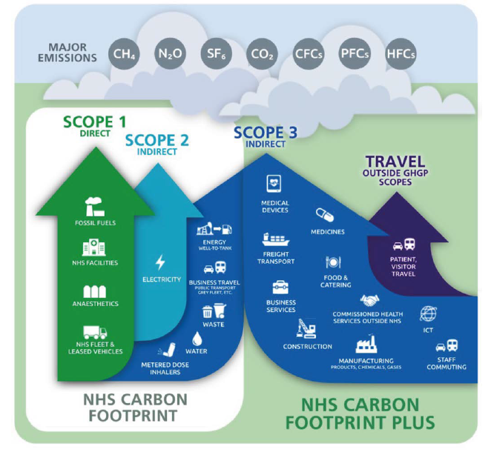
Figure 1. Greenhouse Gas Protocol scopes in the context of the NHS
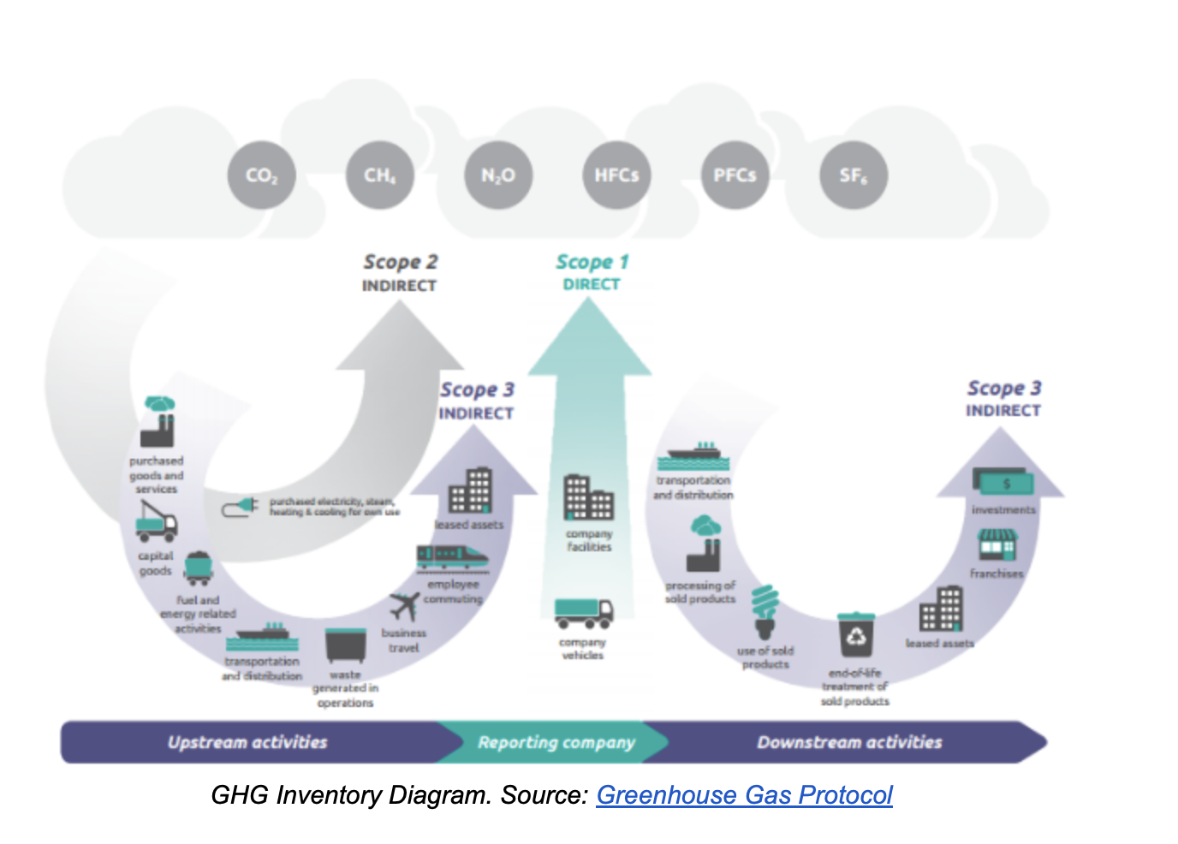
Figure 2. GHG Inventory Diagram

Emissions Reduction Targets

We set a target to achieve Net Zero for our NHS Carbon Footprint by 2030 in 2019. Due to a lack of funding to replace fossil gas power systems we will be unable to meet this target.

The revised target set out in our Climate Emergency Plan for 2026-2031 is that we will reduce our emissions by 50% by 2031, to [28,041.02 tCO2e if scope 1 and 2 or 34,075.72 tCO2e if NHS Footprint]. This remains an ambitious target, reliant on the Public Sector Decarbonisation Scheme funding to decarbonise the Freeman Hospital and two community sites, and the grid reaching net zero. We are working with city partners to establish a Newcastle City North deep geothermal district heat network to support decarbonisation at the Royal Victoria Infirmary. Below is our progress and trajectory.

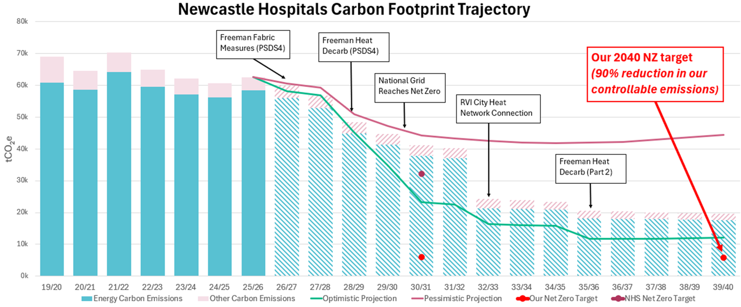

Figure 3: Newcastle Hospitals Carbon Footprint Trajectory

We have set a reduction target for our NHS Carbon Footprint Plus of 90% by 2040, or 61,583.04 tCO2e.

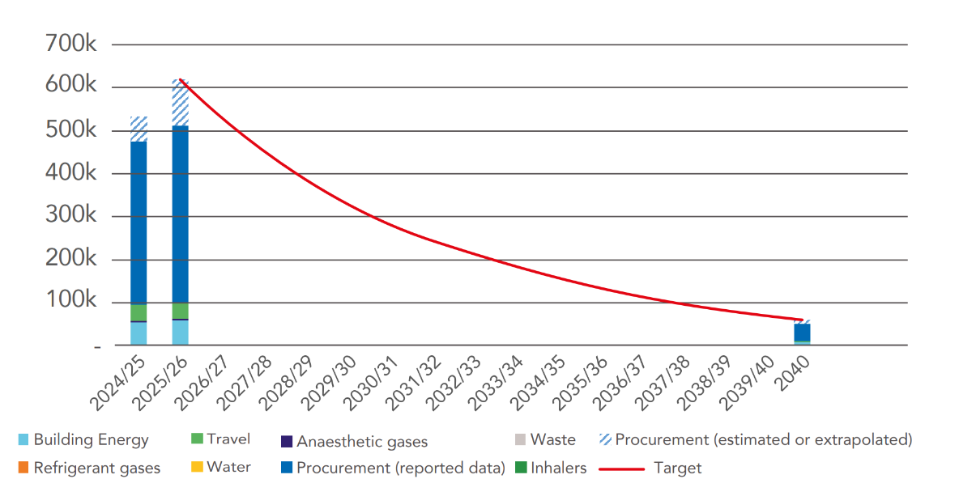

Figure 4: Newcastle Hospitals Carbon Footprint Plus Trajectory

Please see our annual Shine Reports for further detail.

Carbon Reduction Projects

Completed Carbon Reduction Initiatives
The following environmental management measures and projects have been completed or implemented since the 2019 baseline for our NHS Carbon Footprint. The carbon emission reduction achieved by these schemes overall equates to 6,094.68 tCO₂e, a 9% reduction against the 2019 baseline and the measures will be in effect when performing the contract. Some of this reduction will be due to improved carbon factors and grid decarbonisation.

ORGANISATIONAL CULTURE

- We were the first healthcare organisation in the world to declare a climate emergency as a health emergency and commit to fast-tracking the decarbonisation of our services.
- We hold green accreditation with Investors in the Environment for our approach to organisational environmental management.
- Our Sustainable Healthcare in Newcastle (Shine) programme covers eight priority action areas and our Sustainability Team works closely with our network of over 1200 staff Green Champions to reduce our environmental impact in these areas.
- We have received funding from Newcastle Hospitals Charity to assist with projects including: funding for staff led susQI (sustainable quality improvement) projects, clinical leads to drive change in our clinical boards, clinical sustainability fellow who undertook a susQI project, bike maintenance sessions for staff to encourage active and sustainable travel, green the grey projects to make green space more available to staff, improved waste facilities to increase appropriate segregation.

BUILDING ENERGY

- We install energy efficient Light Emitting Diode (LED) lighting as standard on refurbishments and continue to transition our estate from fluorescent to LED.
- We have installed solar panels on the roof of the multi-storey car park at Leazes Wing Royal Victoria Infirmary (RVI), the Day Treatment Centre (DTC) at the Freeman Hospital and Regent Point. There are now 1,293 solar panels across our sites generating almost 350 MWh annually.
- Funding via PSDS Phase 3b to decarbonise Regent Point project completed August 2024. LED lights, heat pumps for the entire energy demand of the building, solar panels and Building Management System (BMS) upgrades. Carbon emission reduction of 40 tCO₂e annually.
- Funding from National Energy Efficiency Fund #3 (NEEF3) of £750,000 for LED lighting at the RVI and solar panels at Freeman Hospital.
- Funding of £92,000 under the Centralised Energy Purchasing Agreement (CEPA) scheme for electrical sub metering at the Freeman Hospital.
- Funding from GB energy of £58,763 for solar panels at the RVI Hospital, completed in early 2026/27.
- Funding of £179,664 for Electric Vehicle (EV) chargers across the RVI and Freeman Hospital.
- Public Sector Decarbonisation Scheme Phase 4 funding (£40.5 million) to upgrade core mechanical, electrical and building-fabric assets across the estates over a 3-year funding period from April 2025 – March 2028, delivering renewal of ageing heating systems, installation of modern, low-carbon heating technologies and improved conditions for staff and patients, estimating a 25% reduction in emissions, estimated at almost 10,000 tCO₂e annually from 2028.

LOWER CARBON CARE

- We limited and then ceased use of desflurane, an environmentally damaging volatile anaesthetic gas, and decommissioned the nitrous oxide manifold at our Freeman Hospital. We continue with clinically led projects to further reduce nitrous oxide waste at RVI, where the gas is still required for paediatric and dental anaesthesia.
- We were the first healthcare organisation in the UK to implement nitrous ‘cracking’ technology, which is used as standard in our Maternity Services at RVI. This equates to a carbon emission reduction of 438 tCO₂e (1%) against our 2019 baseline. The calculation for the volume of nitrous oxygen cracked by the devices was improved this year using more accurate data, in part from the devices themselves and in part using estimates based on the levels of nitrous oxide in the room atmosphere.

TRANSPORT & CLEAN AIR

- We have developed a Travel and Transport Plan to promote and incentivise the travel hierarchy to staff, including personalised travel plans, discounted public transport, cycle to work scheme and cycle storage infrastructure.
- We are recognised as a Gold Cycle Friendly Employer.
- We have commissioned zero-tailpipe-emission all-electric buses from local operator Go North East to run our staff hopper service. This equates to an annual carbon emission reduction of 144 tCO₂e (0.2%) against our 2019 baseline.
- We utilise the Clean Air Hospital Framework (CAHF) as a tool to reduce local and global air pollution. Our current self-assessed score against this framework is 51% “good”. We jointly fund a Clean Air PhD student, with Northumbria University, to progress our CAHF score.

WASTE

- We send zero waste to landfill (and have done since 2011)
- We use reusable sharps containers (and have done since 2004)
- Our waste training and auditing efforts have resulted in sector leading segregation rates, with less than 2% of our waste sent for disposal – the rest sent for energy recovery or recycling.

BIODIVERSITY

- We are hosting a Nature Recovery Ranger from the Centre for Sustainable Healthcare who is working with staff and patients to improve access to green space and therapeutic interventions.
- We are implementing our 30-year Biodiversity Management Plan to improve our biodiversity metric across our estate, knowing that access to nature and green space can improve patient recovery rates and staff health & wellbeing.
- We are developing a Green Spaces and Health Plan for 2026-2031.
- We jointly fund a PhD student from Northumbria University who is studying the links between patient health and availability of green space.

SUPPLY CHAIN

- We have established a dedicated Sustainable Supplier webpage￼, LinkedIn Group and email inbox to promote collaboration and knowledge share in the supplier community. We have over 850 supply chain companies actively engaged in our 5-step Net Zero Supplier Framework, collectively working towards our shared Net Zero target of 2040 for our scope 3 emissions (see note¹). Over 75% of our suppliers (by spend) are providing carbon performance data to support our Scope 3 hybrid calculations.
- We have a sustainable procurement policy with sustainability integrated into our procurement policy. Our steering group and working group meet monthly to implement the sustainable procurement action plan and adopt a ‘buy less, buy better’ approach.
- We work collaboratively with the public sector across the North East to promote sustainable procurement, including via annual supplier events, this year with over 600 attendees.
- We have a 10% weighting on social value on Invitations To Tender for all new procurement.

In the future we hope to implement further measures such as:

BUILDING ENERGY

- Improvements to energy and water metering, to provide enhanced monitoring & targeting
- Delivery of GB energy funded solar panels at the RVI Hospital.
- Delivery of EV chargers across the RVI and Freeman, to support decarbonisation of our fleet and those of our key partners.
- Further roll out of LED lighting, to ultimately achieve 100% coverage, and consideration for installation of solar panels on all viable roof space or surface car parks.
- Evolving our Heat Decarbonisation Plans to include our community properties.
- Continue to apply for government grant funding to deliver our estates net zero strategy.
- Exploration of options to source renewable heat from geothermal energy and/or city heat networks.
- Implementation of plans to shut down air handing units when not in use, in line with national policy.

LOWER CARBON CARE

- Decommissioning nitrous oxide manifold at our RVI site (switching to a lean nitrous oxide supply where there is still a clinical need).
- Further lowering the carbon in our maternity services care pathway by collaborating with European hospitals in our three-year ‘Born Green Generation’ project.
TRANSPORT & CLEAN AIR

- Launch the Travel and Transport plan promoting active and sustainable travel.
- Full electrification of our Trust owned and leased fleet.
- Improve infrastructure for active travel access to our sites, including staff e-bike provision.
- Work towards a sector-leading score of 70% on the Clean Air Hospital Framework (excellent status).
- Increased EV charging facilities for Trust fleet.

WASTE

- Explore innovative opportunities to reduce waste volumes and increase reuse i.e. reusable theatre hats, trialling reusable equipment to replace single use and expanding our food waste recycling.
- Improve reporting of waste in line with the waste hierarchy to show the value of reuse.

BIODIVERSITY

- Progress our 30-year Biodiversity Management Plan to improve our biodiversity metric across our estate.
- Implement the Green Spaces and Health Plan for 2026 – 2031.

SUPPLY CHAIN

- Increase confidence and accuracy in emissions associated with Scope 3 category 1, Purchased Goods and Services, by increasing the proportion of suppliers engaged in our 5-step framework and from ‘extrapolated’ to ‘reported’ data in our hybrid calculation.
- Implement Sustainable Procurement 5-year plan.

Declaration and Sign Off
This Carbon Reduction Plan has been completed in accordance with PPN 006 and associated guidance and reporting standard for Carbon Reduction Plans.
Emissions have been reported and recorded in accordance with the published reporting standard for Carbon Reduction Plans and the GHG Reporting Protocol corporate standard and uses the appropriate Government emission conversion factors for greenhouse gas company reporting.
Scope 1 and Scope 2 emissions have been reported in accordance with SECR requirements, and the required subset of Scope 3 emissions. The full carbon footprint has been reported in accordance with the published reporting standard for Carbon Reduction Plans and the Corporate Value Chain (Scope 3) Standard.
This Carbon Reduction Plan has been reviewed and signed off by the board of directors.

Signed on behalf of the Supplier:
Rob Harrison, Acting Chief Executive

Date: 25 September 2026
Sir Paul Ennals, Chair
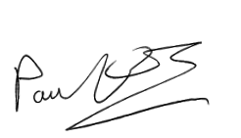
Date: 25 September 2026

Footnotes

https://racetozero.unfccc.int/system/race-to-zero/
https://www.newcastle-hospitals.nhs.uk/wp-content/uploads/2024/06/Climate-strategy-2020-2025.pdf
Our strategy: Caring, improving and learning together (2026 - 2031) - Newcastle Hospitals NHS Foundation Trust
https://www.smartcarboncalculator.com/
https://www.gov.uk/government/collections/government-conversion-factors-for-company-reporting
https://www.england.nhs.uk/greenernhs/a-net-zero-nhs/
https://ghgprotocol.org/corporate-standard
https://ghgprotocol.org/standards/scope-3-standard
https://ghgprotocol.org/scope-3-calculation-guidance-2
https://www.gov.uk/government/publications/environmental-reporting-guidelines-including-mandatory-greenhouse-gas-emissions-reporting-guidance
https://www.newcastle-hospitals.nhs.uk/about/sustainable-healthcare/shine-annual-reports/
https://www.england.nhs.uk/greenernhs/a-net-zero-nhs/
Homepage | GHG Protocol
https://www.newcastle-hospitals.nhs.uk/about/sustainable-healthcare/shine-annual-reports/
https://ghgprotocol.org/corporate-standard
https://www.gov.uk/government/collections/government-conversion-factors-for-company-reporting
https://ghgprotocol.org/standards/scope-3-standard

