NMAHP Researcher Development Institute
Doctoral Fellowship - Accompanying guidance

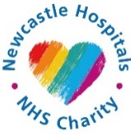
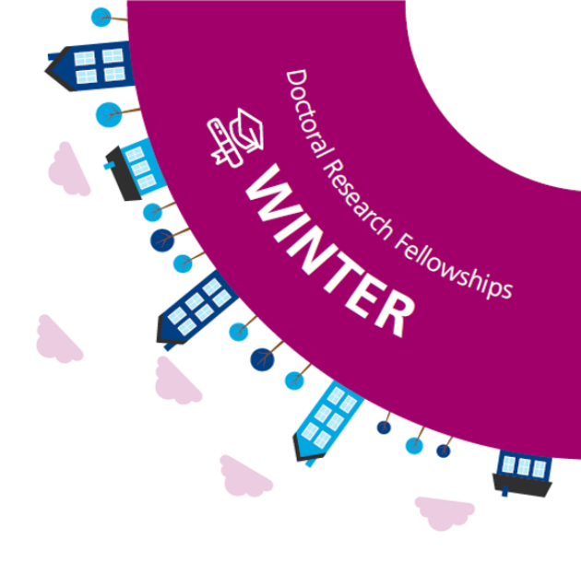
As a recognised leader in the research landscape, The Newcastle upon Tyne Hospitals NHS Foundation Trust is committed to enabling our Nurses, Midwives and Allied Health Professionals (NMAHPs) to develop and lead innovative, world-class care and treatment, to improve prevention, diagnosis, and treatment outcomes for our people.
Research capacity and capability building is a key priority in our overarching Trust Strategy with Pioneering - Ensuring that we are at the forefront of health innovation and research - as a key element. We have a dedicated research priority in our NMAHP Strategy. A key workstream within this is to strengthen our research capacity through innovative research related training and development opportunities, via internally led programmes and partnerships with Higher Education Institutions.
Finally, our Trust’s Research Strategy commits to actively pursue and progress opportunities for integrating research within clinical teams and therefore, within clinical care, and to ensure all researchers are afforded time to progress their research.
Our NMAHP professions connect across multiple boundaries and work closely with patients and service users within broad multidisciplinary teams. They are well positioned to identify and lead research that makes a significant impact and drives positive outcomes.

- What is a Doctoral Fellowship and what does the funding provide?
- The Doctoral fellowship will enable an individual Nurse, Midwife or AHP to undertake a Doctoral research programme with an identified University. The fellowship is part-time and designed to enable the individual to remain present and visible within the clinical department, whilst undertaking the research programme alongside.
The award will fund backfill up to 0.5 WTE of salary and associated tuition fees for the duration of the programme (maximum 6 years). The fellowship will also fund up to £5k project costs, to be discussed and agreed.

- Who is eligible to apply?
- Applications are invited from registered Nurse, Midwife or Allied Health Professionals between Band 5 – 8a as identified via NHS England here: https://www.england.nhs.uk/ahp/role/

- Within the project plan, there is a word limit along with recommended headings – do you have to use these headings?
- The headings are for guidance only. If these headings do not fit with your project, then please use the most appropriate headings for your project

- If I have commenced a Doctoral programme already, can I apply to support the final years of my programme?
- To be eligible to apply, you should not have already commenced a Doctoral programme.

- There is an extra award of £5k for research costs – is it appropriate to include specific training?
- It is reasonable to include anything you think is required. If there are other options to apply for funding for other activities this should be looked at where possible.

- There have been previous issues with the Newcastle Joint Research Office (NJRO) regarding sponsorship and set up fees, is there any agreement in place with the NJRO in regard to this?
- We are piloting a process for covering sponsorship and set up fees for this final award. This will not impact on the project pot of £5k and will not impact on the award, so the successful individual will not be impacted by this internal work.

- Within the application there are no formal costings included at this stage, do we need this?
a. There is a small project costs spread sheet if helpful to plan what the £5k might be spent on. We would encourage applicants to engage with the NJRO for support with any project costings (maximum £5k) and other advice/support around potential sponsorship and set up. To start the process, you will need to submit a Project Initiation Form (PIF) via this link.
- Will there be another doctoral call?
- No. This will be the final doctoral award under the charitably funded Researcher Development Institute.

- When will the interviews be?
- All the details are within the call, for further details please contact the team via the nuth.NMAHPResearch@nhs.net email address.

- There is no mention of a bonding agreement, will this be in place?
- We would hope the successful candidates will choose to continue to develop their clinical academic careers within the trust due to the significant support being offered, however, there are no formal bonding arrangements regarding RDI fellowships. This is in line with the refreshed study leave policy.

- If we need to seek fees/funding to support our project will this be seen as a ‘risk’ if that funding is not secured over the course of the fellowship?
- The panel would look at the whole project, along with funding/ fees, and costs and would be assessed on a case-by-case basis. These monies are to support the development of the researcher and help build research capacity so individuals may need to think about their project and what is realistic/achievable/fundable within the limits of the funding available.

