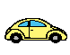
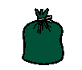

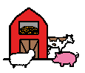
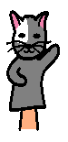


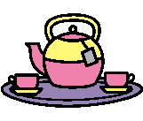
Transport

Use some transport toys e.g. car, bus, train, helicopter and a bridge, garage or road. Ask your child to move 2 items to a place e.g.
‘helicopter and car on the road’
‘bus and train on the bridge’
Objects in a bag
Put some objects or toys in a feely bag in front of him then ask your child to put 3 objects at a time into the bag.

Home corner
Set up a scenario where your child has collects food to put in a shopping basket . Ask them to find 3 objects at a time e.g. ‘apple, carrot and banana’. Or ask them to make dinner for you, give instructions with 3 parts
e.g. ‘put the pizza and potato in the oven’, ‘put a knife and fork on the plate’ etc.

Tidy up time
During tidy up time ask your child to tidy away 3 items at a time e.g. ‘ball , train and car’
Farm yard
Use animal figures and a farm scene. Ask your child to put 3 animals in the farm.
e.g. ‘put pig, cow and sheep in the farm’
Teddy and dolly’s tea party
Place a teddy and dolly in front of your child with a selection of objects then give them instructions e.g. give spoon and
cup to teddy.
Feeding puppets

Use 2 puppets and pretend food . Ask your child to give one of the puppets 2 items of food e.g. ‘give banana and apple to pig’.
Remember...
- Make sure you always have a selection of objects for your child to choose from and that your child can name these objects
- Don’t break the instruction down as this reduces the level of understanding
Understanding Words
Activities to encourage your child to listen and understand instructions with 3 parts

