Learning More than One Language

Learning more than one language is good! Many children speak more than one language.
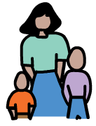
- Your home language is the most important.
- Learning two languages won’t confuse your child but it may take them a little longer to pick up.
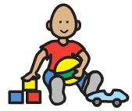
- Your child will be ready to learn English when they are good at using their home language.
- Switching from one language to another shows your child knows both languages well.
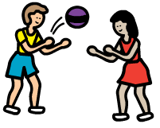
- Avoid ‘teaching’ English and making your child speak English – this can put them off talking.
- Your child will learn English from being around other English speakers, e.g. in nursery or at local groups.
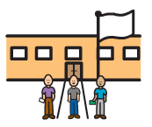
- Don’t worry if your child is quiet when starting nursery/playgroup – this is common when learning a new language.

Only using a few words in their home language = contact a Speech and Language Therapist *

Using home language well but only saying a few English words = allow more time for them to pick up English
* or contact your GP, Health Visitor or early years setting
For more information visit: www.ican.org.uk/help or www.talkingpoint.org.uk

