Information produced by Children’s Cystic Fibrosis Team, May 2021

Review date: May 2024


Information for parents and guardians of school age children
Living with Cystic Fibrosis and Reducing the Risk of Infection
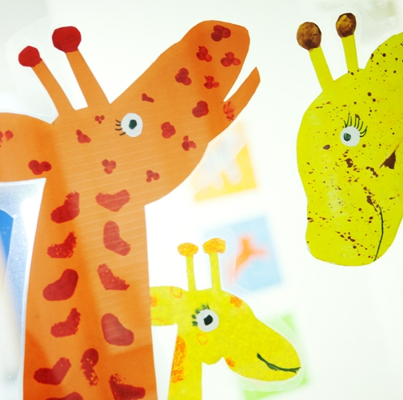



Hygiene
The best way to prevent infection is to wash your hands. Set an example and encourage children to wash their hands too, especially after visiting the toilet, playing outside, or sharing toys outside the home. Your child should avoid sharing drinks with other people or using water fountains.
Coughing can spread viruses and bacteria. It is important that everyone covers their mouth when coughing. Disposal of tissues and careful handwashing after coughing is recommended.
Other people with CF
Many people with CF carry bacteria and other microorganisms in their airways that can be easily passed on to other people with CF. It is really important that your child’s school is aware that your child has CF so they can help minimise the contact your child has with other children who also have CF.
The school will aim to ensure children with CF are in different classes and do not sit closely together in larger gatherings. The CF Nurses can help you to talk to school about this.
Water
When water stands still, bacteria within it can multiply and this increases the risk of infection to people with CF. Swimming pools are clean when they contain chlorine – if unsure, ask. In the home, we recommend running taps and showers briefly every day, and keep them free of a build-up of dirt. When using water play activities, ensure the water is fresh and clean, and avoid any toys that cannot be easily cleaned and dried, such as squeezy toys or water guns. Close the lid of the toilet when flushing.
Sports and hobbies
Children with CF should be able to take part in most of the same experiences as any other child, but you can help reduce the risk of infection with a few simple measures.
Sandpits should be clean and dry; raking before play can help. If your child plays in wet sand or mud, ensure they wash their hands afterwards or they wear gloves. Avoid close contact with hay, manure or compost or going into rooms where hay has been recently raked or moved.
Avoid activities where contaminated water can rise as steam or aerosols, such as tropical greenhouses or hot tubs. People with CF should avoid cleaning fish tanks.
Be mindful that fountains in public gardens may contain contaminated water and should be considered when planning visits. Musical instruments which involve blowing are great physiotherapy – keep them clean and dried properly and avoid sharing between people.
Care of nebulisers
Your child may need to use a nebuliser to take their medication, and it is really important to clean and dry this after each use, and sterilise it at least once a day. The product insert will contain instructions on how to do this.

If in doubt – please ask! The CF team is always happy to answer any questions.

