The Newcastle-upon-Tyne NHS Foundation Trust Fast Track Pathway for Suspected Giant Cell Arteritis (GCA)

There is no single test or validated scoring system which effectively confirms or excludes a diagnosis of GCA. If you are unsure whether to refer we would be happy to discuss the patient. Please follow the flow diagram and consult the notes below where necessary. Referrals to Rheumatology must be discussed with the on-call registrar using the direct dial number.

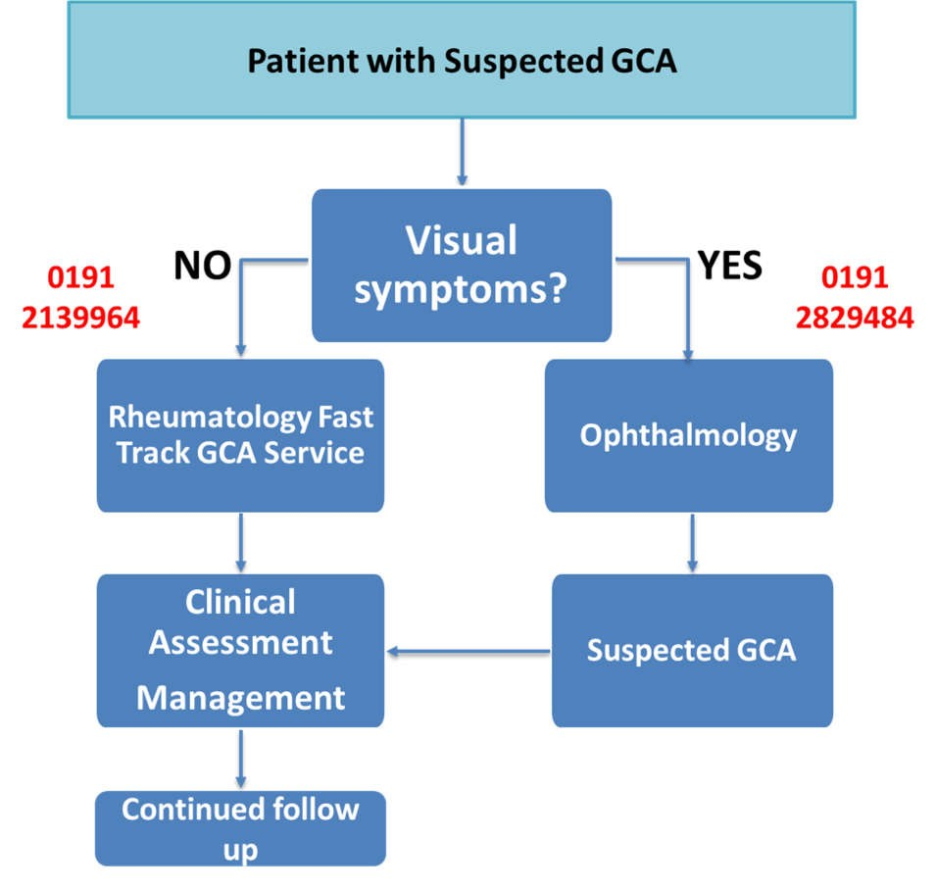
*

* Rheumatology registrar on-call 0900-1900 Mon-Fri, 0900-1300 Sat-Sun. A Rheumatology Consultant is on-call outside these hours and can be contacted via the hospital switchboard.
If you see a patient with suspected GCA and cannot call us we would suggest starting steroids and contacting the on-call at the next opportunity.

Age | GCA ‘does not occur’ under the age of 50 and is rare under 60 years
Visual symptoms | Sudden, temporary loss of vision, double vision, temporary ‘blurring’.  Not a gradual deterioration in sight  Ask specifically about visual symptoms and direct referral to ophthalmology if present (see below)
Jaw claudication | This is a specific symptom for GCA.  Do they get pain in their jaw on chewing – a muscular ache which resolves when they stop chewing?
PMR symptoms | Previous diagnosis of polymyalgia rheumatica or new onset of symptoms
New onset headache | Headache is classically temporal but can be more generalised, occipital or at the vertex
Fatigue / low grade fever / weight loss | Common features of GCA. Occasionally these are the only signs of GCA and we would investigate if CRP / ESR raised and no other cause apparent
Scalp tenderness | Classically pain on combing hair
Other symptoms | Include other neurological features such as TIA / stroke / neuropathy Mouth / tongue pain or ulceration, deafness
Abnormal temporal artery | Some patients have thickened, less compressible temporal arteries. Pulsation may be reduced or absent
ESR /CRP | Do not wait for these results if you have a high index of suspicion for GCA from the clinical picture.  Please check both tests because ESR is less specific in the elderly.  GCA would normally be discounted in patients with CRP <5, assuming they have not had steroids
Advice for GPs and other Health Professionals – could this patient have GCA?

Action to take if GCA suspected:
Refer | → Ophthalmology if visual symptoms. Eye casualty is open at RVI 0815-1630 Mon-Fri and 0900-1130 on Saturday. Phone advice from ophthalmology registrar on-call 0191 2829484. They will refer onto rheumatology if necessary.  → Rheumatology if no visual symptoms. Phone on-call rheumatology registrar at Freeman on 0191 2139964*. If we are going to see them you will be asked to complete an eReferral for ‘Suspected GCA Pathway’, but you still need to phone as the eReferral pathway is not continuously monitored. We will contact patient and arrange to see within 24-48 hours, and arrange investigation (ultrasound, biopsy if necessary) and follow-up if GCA is confirmed.  Please refer via these pathways if you are starting steroids for GCA. Do not refer non-urgently because it is difficult to confirm or exclude the diagnosis once patients are established on steroids.
Start steroids | Start prednisolone if you are referring via the fast track pathway:  - 40mg if no visual symptoms  - 60mg if visual symptoms and /or jaw claudication  - Consider co prescription of PPI, and aspirin 75mg.  We will start bisphosphonate if GCA confirmed and prednisolone continued.

NUTH GCA pathway: Lorenzi/Thompson/Heaney/Rayner/Brown Jan 2026

