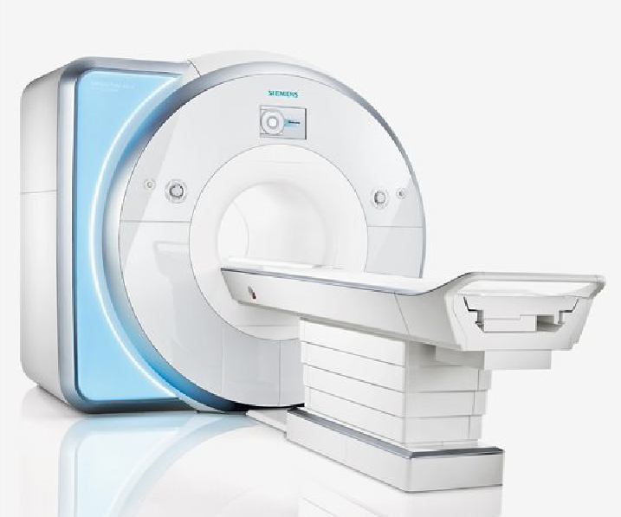 

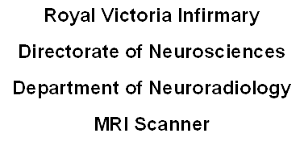

**Introduction**

We have received a request for you to have an MRI scan. This leaflet is designed to give you some information about the MRI scanner, to help you prepare for your scan and to give you some idea of what to expect when you attend.

**What is MRI?**

Magnetic Resonance Imaging or MRI for short is a method of obtaining highly detailed pictures of the inside of your body. A powerful magnet, radio-waves and a computer are used. The technique does not use X-rays and there are no known side effects, however it is extremely important that certain precautions are followed (as detailed opposite).

**Preparation**

You are able to eat and drink as normal. However if you are receiving sedation or an anaesthetic you MUST follow the guidelines in the accompanying letter. Please continue to take any medicines normally prescribed by your doctor.

We have safety lockers for valuable items which cannot be taken into the scanner such as watches, credit cards, jewellery etc. If possible try to leave these items at home.

Eye make-up should also be removed. Mascara contains ‘ferric’ (metal) compounds, which may lead to distortion of images.

**SCANS PERFORMED ON OUR SCANNER WILL SOMETIMES REQUIRE YOU TO CHANGE INTO A HOPSITAL GOWN**

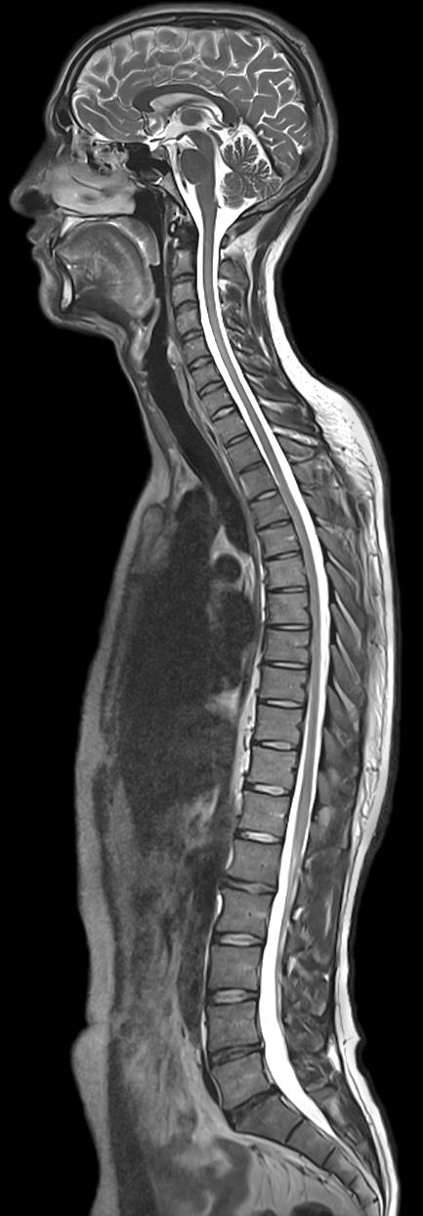

**What happens during my scan?**

As far as the scanning goes all you need to do is lie still throughout the procedure. A radiographer will escort you into the scanning suite and ask you to lie on the scan table. Once you are ready you will be moved into the scanner and your scan will begin.

Whilst the information for the pictures is being acquired the machine will make a series of rapid tapping or buzzing noises. This is a normal part of the scan. We do have a music system which allows you to listen to a CD via headphones. You are invited to bring a CD along with you so you can relax during the scan. The radiographers will be in constant communication with you throughout the procedure (via an intercom) so if you need anything at all you just have to ask.

**How long will my scan take?**

It is difficult to predict, a scan can last for anything between 15 and 50 minutes.

For some types of scan a small injection will be administered into a vein in your arm. This can help us gain further information. You should experience no side effects.

**Will anything prevent me from having an MRI scan?**

Yes: Under certain circumstances an MRI scan may not be suitable if you have any of the following:

**Cardiac Pacemaker, Aneurysm Clips in your head, Cochlear (Inner ear) implants, Metallic fragments in your eyes, some old types of Heart Valves, some types of Aortic Stents, some implanted mechanical pumps and nerve stimulators, also for females if you are or think you may be pregnant.**

**IF ANY OF THE ABOVE APPLY TO YOU IT IS ESSENTIAL THAT YOU CONTACT US ON 0191 282 3946 AND A MEMBER OF STAFF WILL BE ABLE TO ADVISE YOU FURTHER.**

**FAILURE TO DO SO MAY RESULT IN YOU BEING TURNED AWAY WHEN YOU ATTEND FOR YOUR SCAN.**

**Programmable Ventricular Shunts** always need to be checked/reset following an MRI scan and this can only be performed by specialist staff at certain times.

For people with **Nerve stimulators** please bring the operator control device with you (if you have one) so it can be switched off prior to your scan

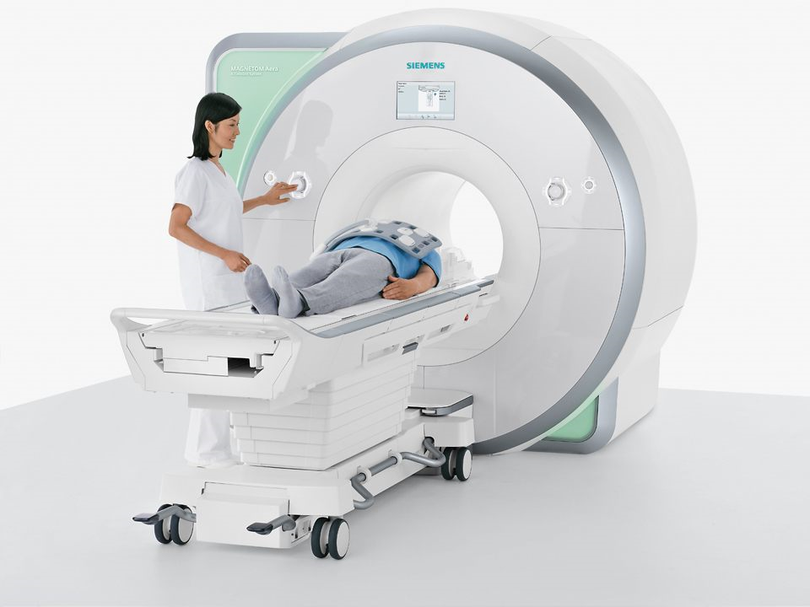

**What if I need an ambulance?**

If you need an ambulance, you must ask your GP surgery to arrange one, giving them three working days’ notice. However, it would be helpful if you could inform the department if you are arriving by ambulance as we will arrange your appointment time to fit with ambulance arrivals

**What if I have any questions?**

If you have any worries or concerns before you attend for your appointment, then please do not hesitate to contact us on 0191 2823946 and we will be happy to help in whatever way we can.

If you have any other questions when you attend for your scan then please ask any of the staff in Neuroradiology.

August 2020

For Review August 2022

**What happens after my scan?**

After your scan has finished the radiographer will not be able to tell you the result. If you have been scanned as an outpatient the result will be sent to the doctor who referred you for the scan**.**

**Where is the MRI scanner situated?**

The MRI scanner is situated in the department of Neuroradiology on **Level 5** in the **New Victoria Wing** at the **RVI.**

The department of Neuroradiology can be accessed via a link corridor from the Leazes wing or alternatively directly from the main entrance off Queen Victoria Road. Neuroradiology and the Neuroradiology MRI scanner are clearly signposted throughout the RVI.

If you have difficulties finding the scanner please ask at reception upon entering the hospital and you will be directed via the shortest route.