

Royal Victoria Infirmary

Directorate of Neurosciences

Department of Neuroradiology

CT Scanner

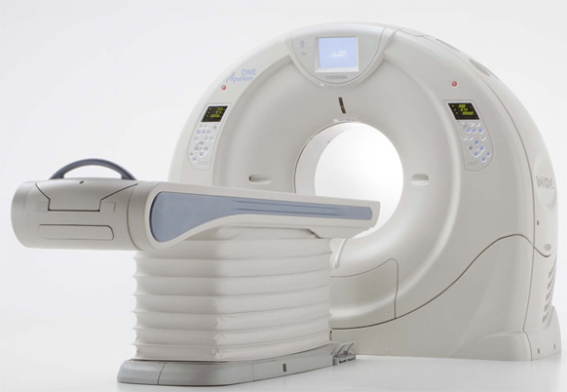

Introduction

We have received a request for you to have a Computed Tomography (CT) scan. This booklet is designed to give you some information about the CT scanner, to help you prepare for your scan and to give you some idea of what to expect when you attend.

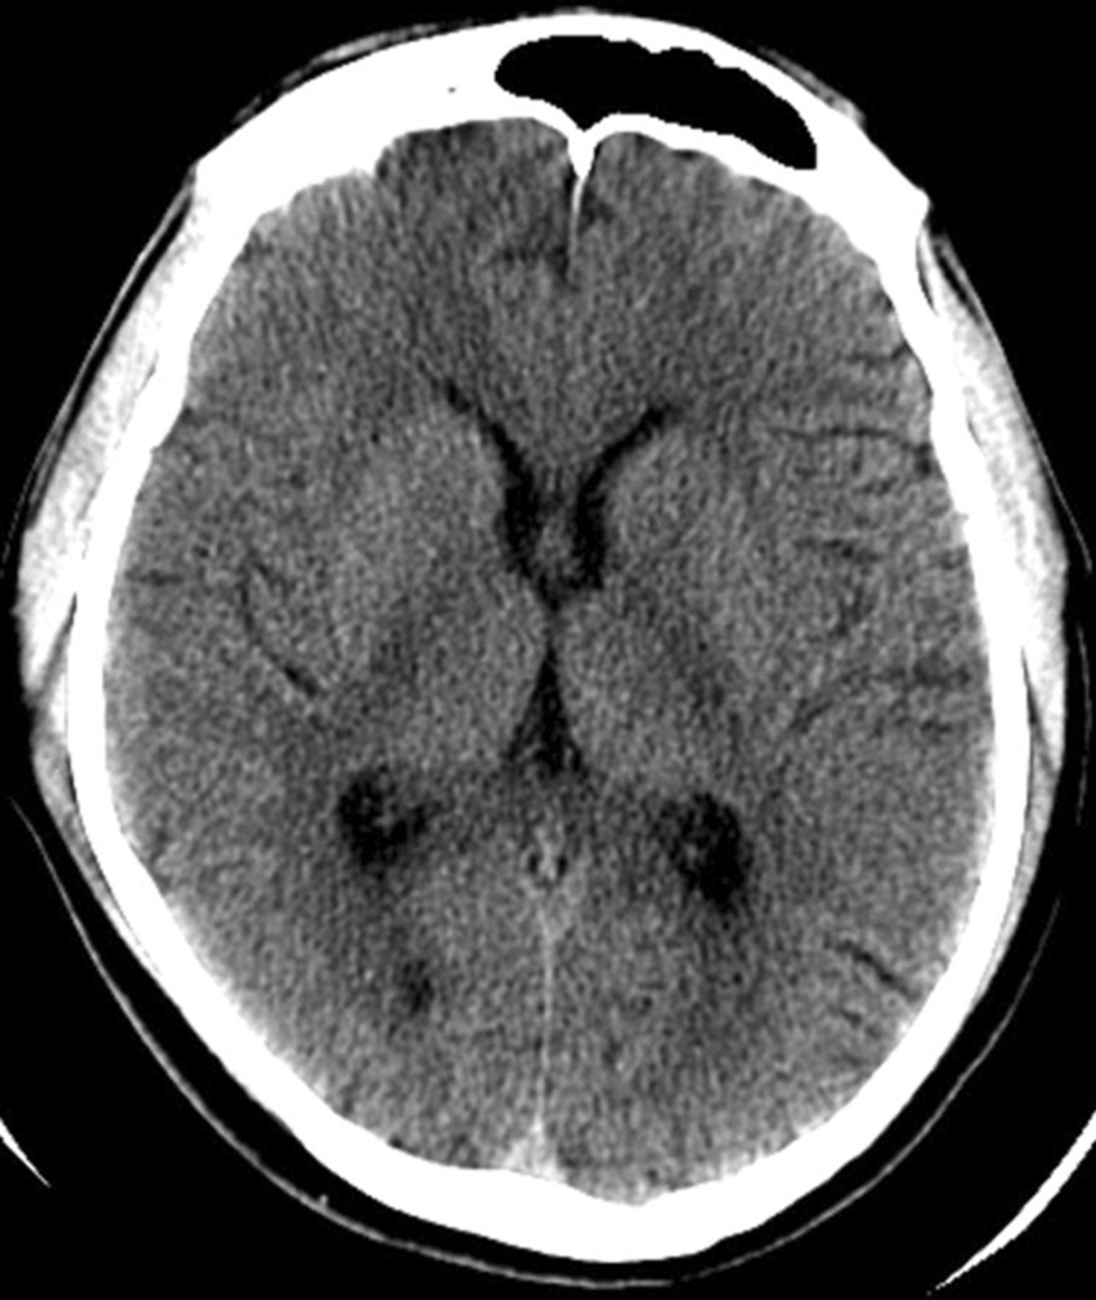
What is a CT Scan?

Computed Tomography or CT for short, is a method of
obtaining highly detailed pictures of the inside of your body.
It is a special type of X-ray using a scanner and computer
equipment, it differs from a standard X-ray as it produces
pictures of cross-sections of the body. CT is excellent in
showing soft tissue, air, fluid, bone, vessels and all other
internal structures of the body, allowing your doctor to
identify any problems.

Preparation

You are able to eat and drink as normal. Please continue to take any medication normally prescribed by your doctor.

If you have had a recent CT examination of the same body region or…

If you have a known Contrast (X-ray dye) allergy please ring the Neuroradiology Department before you attend for your scan on 0191 2823947 between the hours of 9am and 5pm

If you are having a CT scan of your head you will need to remove glasses, jewellery hair slides and dentures with a metal plate before the scan. If you are having an area of your body scanned you may be asked to change into a gown. If possible try to leave any jewellery or valuable items at home.

What happens during my scan?

A radiographer will be carrying out your CT scan.

It is important to tell the radiographer if you are pregnant or think you might be.

A radiographer will take you into the scanning suite and ask you to lie on the scan table. It is important to make sure you are comfortable before the scan begins as it is very important that you remain still during your scan. Once you are ready you will be moved into the scanner and your scan will begin. Whilst the information for the pictures is being collected the scan table will move in and out of the scanner. For some types of scan an injection of x-ray contrast will be required and will be given into a vein in your arm. This can help us gain further information. The side effect you may feel from the injection is an odd taste in your mouth or a warm sensation which will only last a few seconds. There are no side effects from the scan itself.

How long will my scan take?

A CT scan is a painless procedure and usually takes between 10 and 20 minutes, with no side effects or after effects. We always try to scan as near to your appointment time as possible, however emergency cases must take priority.

What happens after my scan?

After your scan has finished the radiographer will not be able to tell you the result. If you have been scanned as an outpatient the result will be sent to the doctor who referred you for the scan.

For further information

Contact details

Neuroradiology Reception on 0191 2823947 between the hours of 8.30am and 7.30pm

The Patient Advice and Liaison Service (PALS) can offer on-the-spot advice and information about the NHS. You can contact them on freephone 0800 032 02 02 or e-mail northoftynepals@nhct.nhs.uk

Useful websites

If you would like further information about health conditions and treatment options, you may wish to have a look at the NHS Choices website at www.nhs.uk. On this website there is an information prescription generator www.nhs.uk/ips which brings together a wealth of approved patient information from the NHS and charity partners which you may find helpful.
Information produced by Lisa Flett, Neuroradiology Manager
Date: Jan 2019
Review date: Jan 2021

Ref no:

