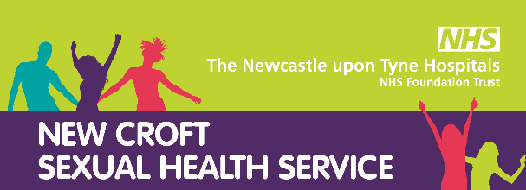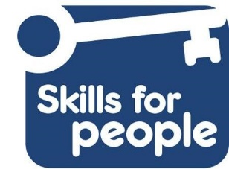

Learning Disability Sexual Health Training -
Supporting People who have a Learning Disability with their sexual health and relationships
This interactive course will develop participants’ knowledge and confidence to support young people and adults with learning disabilities around their relationships, sexuality and sexual health. The course will provide:
- Insight into how learning disability can impact upon an individual’s ability to understand and express their sexuality appropriately
- Understand the rights of people who have a learning disability to understand and experience relationships and sexuality
- Explore your own and others attitudes and beliefs and how these may impact upon the work they do
- Challenge the many myths and misconceptions around learning disability and sexual health
- Explore some of the resources and tools available to support you to talk to young people and adults with learning disability about their sexual health

Dates Available:
6th June 2023
19th September 2023
29th November 2023
24th January 2024

For more information please email: amanda.holmes2@nhs.net
Learning Disability Sexual Health Training
Booking Form
Course Title: | Learning Disability Sexual Health Training
Course Date:

Your name:

Job title:

Team or Department:
Organisation:

Email:

Telephone No:
Work Address (including post code)
Manager’s name:
Manager’s signature:* | Date:
*I am aware that a charge will be incurred for non-attendance without due notice. If you are sending this form electronically your manager will need to send an email confirming his/her consent for you to attend on this date.
Special requirements: (Communication aids, access etc)

Confirmation e-mails will be sent out at least 2 weeks before the course, but please save the date(s) in your calendar in the meantime.
Please note if you do not receive a confirmation email you do not have a place on the course.
By signing this form you are consenting to your details being held on a database which will used for admin purposes only, by New Croft Sexual Health, for example to inform you of future training opportunities.
If you are not happy for your details to be used for this purpose please tick this box

Your Signature: Date:

Please return completed form to nuth.learningdisabilitytraining@nhs.net

