

Dental Hospital Referral Criteria

November 2019

Introduction

The Dental Hospital in Newcastle is primarily a facility for providing clinical experience for undergraduate dental students, student Dental Care Professionals and qualified dentists undertaking further training. It also provides specialist services for referred patients in Oral and Maxillofacial Surgery, Oral Medicine, Orthodontics, Paediatric Dentistry and Restorative Dentistry as well as treatment for the anxious patient and those with special care needs).

The Hospital will only accept referrals which comply with the standards set out in this document. Any non-compliant referrals will be returned to the referrer.

This document has been developed in collaboration with NHS England and forms the basis for acceptance of referred patients into the Hospital for appropriate care. The Hospital accepts referrals from general dental practitioners (GDPs), the community dental services (CDS), general medical practitioners (GMPs) and tertiary referrals from medical and dental specialists.

Making a referral
The responsibility for making an appropriate referral rests with the referring healthcare professional. The General Dental Council in their ‘Standards for the Dental Team’ states that:
‘You should refer patients on if the treatment required is outside your scope of practice or competence. You should be clear about the procedure for doing this.’

The General Medical Council also offers guidance on delegation and referral of patients;
‘Referral involves transferring some or all of the responsibility for the patient’s care, usually temporarily and for a particular purpose such as additional investigation, care or treatment, which falls outside your competence. Usually you will refer patients to another registered medical practitioner. If this is not the case, you must be satisfied that any health care professional to whom you refer a patient is accountable to a statutory regulatory body, and that a registered medical practitioner, usually a general practitioner, retains overall responsibility for the management of the patient.’

Prior to referral for assessment and possible treatment, the referring healthcare professional should discuss with the patient what treatment might involve and refer to any complications that may arise. This will allow the patient to consider the risks before seeing the specialist and to decide what questions to ask the specialist.

Under no circumstances should a referral be made to different departments in a single letter.

It is not acceptable to refer a patient for financial reasons alone.

From time to time patients may be accepted for assessment and possible treatment as private (non NHS) patients by a small number of specific named consultants. Any request for a patient to be seen as a private (fee paying) patient must be made clear in the referral and should be forwarded for the attention of the specific consultant you wish the patient to see.

Accepting a referral
The professional accepting a referral of a patient has a duty to fully understand what the referral is for, and to offer appropriate management. The referring practitioner should be contacted to discuss any changes to the proposed treatment.

A referring clinician should inform a patient that acceptance of a referred patient for consultation does not mean an acceptance for provision of treatment in the Hospital. Acceptance for treatment will depend upon the treatment required and the most clinically appropriate location for that treatment; for many patients the most appropriate course of action is likely to be the provision of a treatment plan which their dentist will be expected to complete.
Whilst a patient is awaiting an appointment for consultation following referral, emergency and routine treatment remain the responsibility of the referring clinician.

The referral letter
The referring practitioner must send appropriate information to enable the receiving practitioner to have an accurate picture of the problem and any accompanying difficulties. The referral letter should encapsulate the results of the referring practitioner’s examination and diagnosis. It is recommended that the NUTH referral form is completed to ensure all relevant patient details are received. A number of referral forms have been developed; one general one (Appendix A), one for sedation (Appendix B), one for the Child Health Department (Appendix C) and one for Oral Surgery (Appendix E). Any relevant test results should be included with the referral letter.

Alternatively, a letter should be clearly written or preferably type written, and should contain the information set out in the guidance below. Faxed, hand-written letters are often very difficult to read and should be avoided. The patient should be given a copy of the referral letter.

Radiographic images
Radiographic images that are printed on the referral letter, on separate paper or faxed to the Hospital will not be accepted. Paper copies have a suboptimal resolution and poor reproduction which may lead to under diagnosis and are indefensible medico-legally. Acceptable images are:

- The original, conventional film images;
- Digital images printed on photographic paper;
- Those on CD.

Further, all images should have right and left identifiers, the name of the patient and the date on which the images were taken.

All images will be scrutinised for diagnostic quality when the referral is received. If no images are sent with the referral and patients subsequently tell us that they have had recent radiographs taken, we will not take further images and the referral process will be put on hold whilst we request, and are sent, the relevant films.

Patient Advice
Patients should be advised that they should not expect that any proposed treatment arising from that consultation will be provided at the Dental Hospital.

Patients should be advised that once treatment is completed they will be referred back to their dentist.

Triaging of patients
All referrals for assessment to the Dental Hospital are triaged by senior clinical staff according to the description of the case and the urgency with which patients need to be seen. There are a number of consultants in Newcastle Dental Hospital and School, and pooled waiting lists for each department are in operation.

Inadequate or inappropriate referrals
As a consultant receiving the referral has a responsibility to ensure that the request for advice or treatment is fully understood, referral letters that do not include adequate information will be returned to the referring practitioner for clarification.

Each individual department in the Dental Hospital has specified the information required for referral to that department. Please check the criteria to determine relevant information which is required for each specific type of referral.

Some patients request referral via their general medical practitioners for routine care. They should, in the first instance, be encouraged to seek treatment from a general dental practitioner in the primary care sector locally, and referring medical colleagues should be aware of the restrictions in acceptance of patients for routine care as above and ensure that this is communicated to the patient prior to any referral.

The Hospital is not able to provide treatment of a routine nature for patients based on their ability or willingness to pay for that treatment whether it is to be provided by either the present General Dental Services contract or is only provided under private contract by the referring practitioner.

DNAs and cancellations policy
The directorate complies with the DNA policy of the Trust in that if a patient fails to attend an appointment for a consultation the patient will be discharged back to the care of the referrer. The consultant involved does have discretion to provide another appointment but this will be only be exercised in exceptional circumstances.

Following referral
All referring practitioners will receive a letter following assessment and once treatment is complete or if the patient fails to attend or complete treatment.
If patients are accepted for treatment by consultant staff, postgraduate trainees or dental/ hygiene and therapy students, it is on the understanding (of both the patient and the referring dentist) that a specific course of treatment will be undertaken and then the patient will be discharged back to the dental primary care setting for review and continuing care.

Dental Emergency Clinic (DEC)

Role of DEC
The role of the dental hospital emergency clinic (DEC) is to contribute to the teaching of undergraduate dental students and the training of junior qualified staff in the management of patients with acute conditions. As such, emergency care is provided for patients who are receiving routine primary dental care from undergraduate students and in addition to this, emergency treatment is provided to members of the public who present seeking treatment. The department does not routinely provide emergency care for patients receiving ongoing care from a primary care dental practitioner.

Specific information - DEC
The clinic is open Monday to Friday (excluding statutory holidays and bank holidays) from 08.30 each morning, and the actual number of patient places available will vary depending on the number of staff and undergraduates present.

Unlike most departments, the DEC does not use a triage system to determine clinical need and patients are seen on a first come - first served basis. It is not unusual for the available capacity for both the morning and afternoon sessions to have been allocated by mid-morning.

Patients, who present at the department after the clinic capacity has been allocated may, at the discretion of the supervising clinician and subject to time and staff availability, be seen on the clinic.

If the available capacity has been utilised patients can potentially access other available provision for urgent dental care such as general dental practitioners, community dental service, dental access centres, evening and weekend emergency dental services or accident and emergency departments. The Dental Hospital main reception is able to provide information to patients regarding these services on request.

Patient acceptance criteria
There are no selection criteria for this department.

Restorative Dentistry

Role of the Department of Restorative Dentistry
The role of the specialist service in Restorative Dentistry is to provide diagnostic and treatment planning advice to referring practitioners. The intention of the consultants in Restorative Dentistry is to work in partnership with the referrer, particularly with those responsible for the routine management of the patient. This means that the patient will almost always be referred back to primary care for specific items of treatment or all of the recommended treatment with a detailed treatment plan.

Acceptance criteria for treatment by staff
The following categories of patients will normally be accepted for treatment by qualified dental staff:
- Oncology patients: patients who have undergone head and neck cancer resections, obturators and post-radiotherapy management. However, patients who have a regular dentist will need to continue to see them or the Community Dental Service for routine treatment, in a shared care arrangement with the Dental Hospital;
- Developmental defects: cleft lip and palate, severe hypodontia, joint orthognathic and/or orthodontic cases and patients with amelogenesis / dentinogenesis imperfecta ;
- Trauma: severe trauma (such as seen in patients following road traffic accidents) involving significant damage to the dentoalveolar complex;
- Severely medically compromised patients, e.g. as medically required: patients with bleeding disorders which require liaison with haematology, immuno-compromised and organ transplantation
- Any other patients with special needs.

Acceptance criteria for treatment by students
The primary pathway for any patient wishing to apply to receive treatment via undergraduate dental students for simple routine dental treatment is via a web based self-referral portal. The portal can be found at. https://www.ncl.ac.uk/dental/engagement/public/ The portal and subsequent waiting list is intermittently opened so that an initial assessment appointment, on the undergraduate student clinic, can be arranged. At this appointment an oral health assessment will be undertaken and an evaluation of the treatment required will be made to establish whether a patient’s needs fit within simple restorative treatment deliverable through the undergraduate learning environment. Patients with more involved treatment needs will be advised to seek the input of a primary care practitioner in the first instance.

On completion of a course of treatment patients will be discharged with advice to be seen via primary care dental services for their ongoing care. This is in order to ensure equitable access to the student clinics and a steady flow of new patients into the learning programmes in the Hospital. Patients who have received a course of treatment within the last two years will not usually be accepted back into the undergraduate student clinics for long term ongoing care.

There are select groups of patients requiring specific treatments, for example uncomplicated Endodontics and Removable Prosthodontics, who may be accepted into the student programmes by direct referral from a primary care practitioner if their treatment need aligns with the following:

The following must be made clear to patients by the referring practitioner that:
- they are being referred for treatment by student dentists who are under supervision and not by the specialist services;
- they will attend an initial assessment clinic that may determine that their treatment needs to not fall within the scope of simple treatment that can be delivered by a student learning programme leading to them being referred back to primary care;
- they will be expected to see their primary care practitioner for all other routine and emergency care;
- they will be discharged back to the primary care practitioner on completion of the specified items of treatment;

Endodontics
Patients needing uncomplicated root canal treatment are required for undergraduate training during clinical term-time. Suitable cases (see below) may be accepted for treatment, dependant on the needs of the undergraduate teaching programme at the time of referral.

Suitable cases include:
- uncomplicated initial root canal treatment of anterior, premolar and molar teeth;
- teeth which have been accessed and minimally instrumented for emergency pain relief are acceptable;
Teeth should be
- restorable
- accessible and uncomplicated to instrument;
Patients should be
- in good general health
- aware of and able to commit to treatment over several, lengthy appointments.

Referrals for undergraduate treatment should be clearly marked as such and a recent diagnostic periapical radiograph (complying with requirements for images sent to the Dental Hospital) must be included. Patients will be returned to the referring dentist for review and definitive restoration when the root canal treatment is complete.

Prosthodontics
Patients requiring new or replacement removable prostheses may be suitable for treatment via the undergraduate student clinics through a direct referral from a primary care practitioner. Edentate patients requiring complete dentures; orally healthy and stable partially dentate patients who do not require any other dental treatment may be accepted. Referrals for undergraduate prosthodontic treatment should be clearly marked as such with a clear history of any previous management. Patients will be returned to the referring dentist for review and ongoing care when student treatment is complete.

Inappropriate referrals
- Patients who take anticoagulants (Warfarin) do not require primary dental treatment in hospital unless their INR exceeds 4.0 and referrals for such patients must include their INR range.

Endodontics
Patients who may benefit from surgical endodontics should be referred to the Department of Restorative Dentistry and not Oral Surgery in the first instance.

Referrals for endodontic care or an endodontic opinion will NOT be accepted unless accompanied by radiographs of appropriate diagnostic quality.

Acceptance criteria for treatment by staff
Treatment will usually be limited to a ‘troubleshooting’ service (e.g.: overcoming anaesthetic problems for pulp extirpation, removal of old root fillings where this has proved difficult under the care of the referrer, canal location, removal of fractured instruments or posts, perforation repair), which aims to overcome immediate challenges and allow treatment to be successfully completed in primary care.

Priority will be given to the following cases:

- patients at medical risk from tooth extraction e.g. bisphosphonate treatment, post-radiotherapy;
- anterior and premolar teeth;
- Primary and re-treatment of functionally and aesthetically important teeth with a strong long-term prognosis;
  - generally with a minimum 2mm of coronal tissue above gingival level;
  - prognosis for endodontic intervention is better than extraction and prosthetic replacement;
- management of dental trauma and its consequences, including root resorption;
- investigation of atypical pain;
- investigation of suspicious pathology;
- surgical endodontics.

Inappropriate Referrals
The Department will generally not accept referrals for endodontics for the following:
- unrestorable teeth;
- teeth of poor prognosis;
- poorly maintained mouths;
- treatment will not be offered for second or third molars unless there is a compelling need for their preservation on local dental (e.g.: avoidance of a free-end saddle situation) or systemic (e.g.: avoidance of extractions in patients taking bisphosphonates) grounds, unless the treatment is deemed suitable as part of the undergraduate programme as outlined above.

Referrals for endodontic surgery on molar teeth will generally not be accepted.

Removable Prosthodontics (complete and partial dentures)
The Department provides a diagnosis, treatment planning and advice service for patients registered with a General Dental Practitioner who require removable full or partial prostheses. It provides specialist prosthodontic care.

All patients referred to the Department should have good oral health; that is, dentate patients should have a good level of oral hygiene and have no active caries or incompletely restored teeth. Attempts must have been made to alleviate problems associated with dentures that have been provided by the referring practitioner in the preceding few months.

If, having assessed the patient’s existing prostheses, it is felt that the provision of treatment is within the scope and expertise of a general dental practitioner colleague, with appropriate advice, it is expected that patients will return to their practitioner with an appropriate treatment plan.

Acceptance criteria for treatment by staff and postgraduate students
Patients with particularly difficult anatomy resulting from surgical intervention, trauma or clefts. In these instances the referring practitioner is expected to provide all other dental care for the patient.
Where it is clear that all efforts have been made by the practitioner to address the patient’s issues, or in the case of re-referral, where the treatment plan provided has been accurately followed, patients will be accepted for prosthodontic treatment within the capacity of the service.

Fixed prosthodontics
Relevant radiographs of good diagnostic yield and appropriate study models must be included where available. A full history of the problems reported and an indication of what advice is being sought should be provided. Where there is significant clinical or radiographic evidence of failure of a crown or bridge it is expected that this is communicated to the patient and an attempt made to remove it and assess future restorability before referral. This also applies to (post-) crowned teeth with failing endodontics. A crown, bridge or veneer deemed to be failing within 1 year of provision is regarded as the responsibility of the providing practitioner to correct.

Advice on appropriate methods of removal and management of fixed restorations will be provided. Patients referred for the rectification of problems or replacement of crown and bridgework or veneers provided out with the Dental Hospital will not be accepted for treatment except when the case would be suitable for training purposes.

Tooth wear
A full diagnostic and advisory service is available. A period of monitoring with respect to the rate of progression is advised prior to referral. Referrals should be accompanied with serial models or photographs to show the rapidity of the tooth wear where appropriate. In younger patients it would be expected that a full dietary analysis would have been undertaken, fluoride mouthwash advised and appropriate preventive advice given prior to referral. Advice on the options for management of tooth wear will be provided.

Implants
Acceptance criteria for treatment by staff or postgraduate trainees
In most circumstances other treatment options must have been tried prior to referral for assessment.
Requests for detailed implant planning from dentists who are intending to provide the implants are not normally accepted.
The following categories of patients will be considered for the possibility of treatment:
- developmental reasons for missing teeth, usually where the adjacent teeth are intact
- missing teeth as a result of trauma.
- severe denture intolerance (particularly where this has arisen following treatment for head and neck cancer). A formal psychological assessment may be sought to determine the severity of the problem
We would expect dentate patients to be caries-free, have no active periodontal disease and be able to demonstrate a good standard of oral hygiene.
Please note that the Dental Hospital is not able to offer treatment for the following:
- completion of implant treatment commenced elsewhere
- correcting prosthodontic or peri-implant problems in relation to implant treatment carried out elsewhere
- maintenance of implants and implant restorations provided elsewhere
Following completion of implant treatment, it is our usual practice to discharge patients from the Dental Hospital for ongoing follow up in primary dental care.

Periodontics
The specialist service in Periodontics provides a comprehensive diagnostic, treatment planning, and advice service for patients with periodontal diseases.

All referrals to the Periodontics Department will be expected to contain the following information:

- the reason for the referral;
- a summary of the patient’s and dentist’s current concerns;
- a summary of the current clinical findings including BPE scores and detailed periodontal indices;
- a summary of treatment already provided and, with it the response to treatment;
- details of known risk factors including smoking history and medical history;
- evidence of longitudinal monitoring (with radiographs and indices) of patients for whom there appears to be periodontal deterioration.

In normal circumstances referrals will only be accepted and treatment offered for patients when there have been initial attempts to undertake stabilisation through treatment in primary care. We require the following to have been undertaken:
- appropriate oral hygiene instruction with particular emphasis on interdental cleaning;
- supra and sub gingival scaling and polishing;
- root surface instrumentation with the use of local anaesthetic.

Patients accepted for periodontal treatment should continue to see their own GDP for routine dental examinations. There will be occasions when the GDP will be requested to undertake other or additional treatment such as restorations, endodontics, or the provision of immediate or partial dentures when such treatment is indicated either before or concurrent with the periodontal management.

The Periodontics Department is not able to offer long-term provision of maintenance/supportive care. On completion of periodontal treatment, pre- and post-treatment charts will be sent to the GDP for their information in future monitoring and maintenance of the patient. A recall interval programme of periodontal care in the primary care practice will be suggested. Re-referrals will not be accepted if the supportive care regimen has not been provided.

If patients are to be re referred for further opinions and treatment we expect that the appropriate supportive care has been provided.

Acceptance criteria
Patients who will be considered for treatment in secondary care will include those with:
- advanced chronic periodontitis;
- aggressive periodontitis;
- medical conditions, medication histories or syndromes that directly affect periodontal status such as: uncontrolled diabetes; patients with drug-induced gingival enlargement; idiopathic gingival fibromatosis; necrotising periodontitis; and blood disorders.
- mucogingival problems, gingival recession or other periodontal defects for which surgery may be indicated.
- periodontal-endodontic lesions.

Inappropriate referrals
Patients who should not be referred for specialist advice and treatment planning are those:
- with only gingivitis;
- with poor oral hygiene or who are non-responsive to, or non-compliant with initial hygiene phase therapy provided in primary care;
- with BPE scores of 2 or less.

Temporomandibular Disorders (TMD)
Many patients with a diagnosed TMD can effectively be managed in general dental practice using straightforward conservative measures such as a combination of reassurance, remedial jaw exercises and a soft splint. Prior to referral, we strongly encourage dentists to provide conservative measures for the patient with a clear explanation of the nature of the condition affecting the TMJs and jaw muscles as there is now evidence that this helps ease the patient’s anxieties during subsequent management. Where there are clear joint or muscle symptoms it is reasonable to call the condition TMD and give a brief explanation, even if you are not totally confident with diagnosis. Advice on diagnosis, patient explanation and jaw exercise sheets can be downloaded from: http://www.ncl.ac.uk/dental/AppliedOcclusion

A few patients with TMD may have characteristics indicating they may be more difficult to manage and may merit referral before any treatment though we would again encourage a provisional diagnosis and reassurance.

Sometimes there is doubt over the diagnosis of chronic facial pain, especially when it is accompanied by unexplained, exaggerated or bizarre symptoms. In the absence of potential dental problems or any evidence provisionally suggesting TMD these patients should be referred to Oral Medicine.

To avoid delays with arrangements for hospital appointments, patients with acute symptoms of TMD are best managed in general practice in the first instance. These cases are characterised by acute onset of pain and particularly by painful limitation. Rest and analgesics are needed in the short-term but if muscle symptoms predominate, Diazepam elixir can be prescribed (5ml spoonful provides 5mg Diazepam). Up to 10mg of Diazepam can be prescribed in a day but patients must be advised not to drive or operate machinery

Acceptance criteria for TMD
- multiple unsuccessful treatments
- psychological distress
- occlusal preoccupation
- fibromyalgia (generalised muscle pain affecting most of the body)
- disc displacement without reduction (closed lock).
Oral and Maxillofacial Surgery

Oral and Maxillofacial Surgery is a joint medical and dental speciality that deals with the surgical management of disease and deformity of the mouth, jaws and face.

The scope of the speciality includes the diagnosis and management of facial injuries, head and neck cancers, salivary gland diseases, facial disproportion, facial pain, TMJ disorders, impacted teeth, difficult or failed extractions, medically compromised patients requiring oral surgery, cysts and tumours of the jaws and oral mucosa diseases such as potentially malignant disorders, mouth ulcers and infections'.
Urgent referral for abnormal oral lesions
If a lesion is suspected as being a possible oral malignancy this should be clearly indicated on the referral letter in addition to the referral being marked as ‘Urgent – two week referral’ indicated in the referral letter.

Patient acceptance criteria
The unit accepts referrals for oral surgical conditions with the exception of implantology, subject to the criteria set out in the table below.

A specific Oral Surgery referral form has been developed which is shown at Appendix E

All referrals should be accompanied by appropriate imaging where relevant. The imaging should be of diagnostic quality.

General Dental Practitioners (GDP) | Newcastle OMFS
Tier 1 | Tier 2 | Tier 3
Routine extractions and simple dento-alveolar surgery within the competency of a GDP (raise flap, minor bone removal, root division and elevation) as defined by the GDC undergraduate learning outcomes | Extractions of ‘special difficulty’ with associated pathology (such as ankylosis) for single and multi-rooted erupted teeth. Failed extractions | Advice only
Management of minor dental trauma (not including alveolus) | Removal of wisdom teeth as indicated by NICE (www.nice.org.uk.March 2000, revised 26.4.04) | Removal of complex impacted/ectopic/supernumerary teeth (in conjunction with an orthodontic treatment plan)
Patients taking warfarin with INR<4 for routine extraction | Removal of buried roots and fractured or residual root fragments which  are covered by bone | Management of extensive or sinister soft tissue lesions
Patients with TMD where ‘advice’ and simple splint therapy are indicated | Removal of simple impacted/ectopic/supernumerary teeth (in conjunction with an orthodontic treatment plan) | Management of oro-facial pain
Patients taking oral bisphosphonates for simple extraction or those taking oral steroids for less than month at a dose of 5mg or less | Simple exposure of teeth (removal of gum and or bone over the surface of the tooth preventing eruption) | Any other oral or maxillofacial conditions
 | Surgical endodontics on single rooted anterior teeth, which have a satisfactory orthograde root filling. A radiograph of diagnostic quality must be included with the referral. (NB. Re-RCT may be more appropriate) | Complex cases possibly requiring a GA
 | Removal or enucleation of simple dental cysts
 | Benign minor soft tissue surgery including removal of simple fibro-epithelial polyps, mucoceles and denture induced hyperplasia (with no sinister features)
Sedation Department

The Sedation Department accepts referrals of dental patients who require conscious sedation to undergo dental care. Sedation services provided by the Department are primarily intravenous sedation for adults and inhalational sedation for children. Other types of sedation will be provided where clinically indicated. In order to be considered for treatment patients must fulfil the criteria outlined below. Patients accepted for treatment will be allocated to an appropriate treatment session or waiting list.
* Note that children (<16 years old) requiring sedation should be referred to the Department of Child Dental Health for initial assessment.

Types of Patients Accepted for Treatment
Patients unable to undergo dental treatment under local analgesia alone, who require treatment using pharmacological sedation. Examples include patients with:
- Dental anxiety or phobia
- Needle phobia
- Prominent gag reflex (which prevents dental treatment)
- Failed sedation in primary care
- Behavioural problems
- Medical issues (see detailed criteria below)
- Special needs (learning/physical disability - see further advice below)

Teaching and Training
The Department is a teaching and training unit. Many patients will be treated by 5th year undergraduate dental students or postgraduate practitioners, working under supervision. Dental training grade staff (DF3/GPT) also undertake treatment. Treatment provided by senior staff is primarily for patients who present with more complex problems including severe anxiety states, behavioural problems, failed sedation in primary care (e.g. difficult cannulation), and concurrent medical/psychological/disability problems.

Complex or advanced restorative procedures (e.g. crown/bridgework, veneers, endodontics) will only be undertaken if the patient fits all of the following criteria:
- has successfully completed routine care under sedation
- shown that they can maintain good oral hygiene
- is necessary to maintain the anterior dentition only

Complex or advanced restorative procedures are not undertaken by dental students under sedation as the time required by the students to undertake these procedures would lead to an unsatisfactory length of time for patients to undergo sedation.

Referral Letters
Referral letters must include the following, in addition to standard patient information:
- Reason for requesting sedation (e.g. dental anxiety/phobia, severe gag reflex, behavioural management, disability, potential traumatic/surgical procedure)
- Past dental history and response to attempted treatment under local analgesia
- Details of oral examination, dental diagnosis and treatment requested (specify for each tooth)
- Full medical history and list of all systemic drugs & allergies
- Appropriate radiographs
Referrals will not be considered unless the information above is provided. Incomplete referrals will be returned to referring practitioners. It is advised that the Sedation Referral Proforma is completed (Appendix B) and that the patient has completed a CORAH or MDAS anxiety scale questionnaire.

Medical Criteria
Patients referred to the Sedation Department for intravenous sedation need to fulfil specific medical criteria to be accepted for treatment. The Department provides a sedation service which adheres to criteria based on national and local recommendations. Each patient will be individually assessed to determine their medical suitability for sedation.

Patients normally accepted to Sedation Department for treatment:
- Patients with no systemic disease.
- Patients with mild to moderate systemic disease, not interfering with normal activities.
e.g. well-controlled asthma, mild hypertension (BP<160/95), non-insulin dependent diabetes,
well-controlled thyroid disease, mild anaemia, obesity (BMI up to 30), learning disability (mild).
- Patients with severe systemic disease which limits activity, but is well controlled. If the disease is well controlled, patients in this category may be accepted for intravenous sedation e.g. hypertension (BP ≤ 170/100), insulin-dependent diabetes, obesity (BMI ≤ 36), psychiatric conditions (neuroses, depression), drug abuse (cannabis), multiple sclerosis, Parkinson’s.

Patients aged 16-70 years are accepted for intravenous sedation but outside this age range need to be individually assessed as to their suitability.

Management of patients who do not fit above criteria
There are a number of patients who cannot be accepted for intravenous sedation and who should ideally be managed under local analgesia alone or with inhalation sedation:

- Patients with severe systemic disease which limits activity, and is poorly controlled or complex e.g. hypertension (BP>170/100), myocardial infarction <3 years, stable angina, cardiac arrhythmias, severe chronic bronchitis, morbid obesity (BMI more than 36), alcohol dependence, severe psychiatric conditions (psychoses), grand mal epilepsy, drug abuse (cocaine, heroin), Alzheimer’s, systemic medication posing major interaction with sedation drugs.
- Severe systemic disease which is life-threatening e.g. myocardial infarction <6 months, unstable angina, heart failure, implantable defibrillator, Wolf-Parkinson White, cerebrovascular accident, uncontrolled diabetes, severe emphysema, organ transplantation, motor neurone disease, myasthenia gravis.
- Patients who are pregnant.

However, if intravenous sedation is required it should be provided by a specialist anaesthetist. The Sedation Department does not provide an anaesthetist-led sedation service. The patient should be referred to a local anaesthetist-led day-case treatment unit. This will normally be provided by the community dental service local to the patient’s home address. If the local Community Dental Service does not provide the appropriate service then the patient should be referred to the Special Care Team.

Patients with Special Needs
Patients with special needs are best seen more local to home and should be seen by the local community dental service. Please refer to your local Community Dental Service Referral Criteria. If the patient does not meet the criteria of referral to the local Community Dental Service, the patient should be referred to the Special Care Team.

If you are unsure whether the patient you plan to refer fulfils the acceptance criteria, please telephone the Sedation Department (0191-2825306) for advice.

Paediatric Dentistry

General referral criteria

The department accepts patients from birth until their 16th birthday.

If patients are accepted for treatment, it is on the understanding (of the patient, parent and the referring dentist) that a specific course of treatment will be undertaken and then the patient will be discharged back to the dental primary care setting for review and continuing care. The referring practitioner remains responsible for ongoing care for the patient during this treatment course.
A senior clinician triages referrals and a pooled waiting list is in operation. Undergraduate students, specialists, training grade staff and consultants may treat patients accepted for treatment.

The acceptance criteria for referral of patients are:
- Caries in pre-cooperative children and uncooperative older children, where dental treatment under local anaesthesia is not possible, and who may require oral rehabilitation or extraction under general anaesthesia or inhalation sedation. Efforts should be made by the referring practitioner to identify a general anaesthetic service in their local area, for example within a local hospital or community service before referring to the Dental Hospital.
- It is inappropriate to refer a child for caries management without having provided dietary advice, oral hygiene instruction and some attempt has been made to acclimatise the patient, i.e. introduction to equipment, placement of temporary dressing. Before referral, there must have been an attempt at age appropriate pharmacological or non pharmacological behaviour management, either with a General Dental Practitioner or with the Salaried Primary Care Dental Services (Community Dental Service).
    - Children who have sustained complex dentoalveolar injuries requiring specialist opinion and/or treatment.
- It is NOT appropriate to refer a child who requires a simple composite tip.
    - Medically compromised children where treatment planning is difficult or treatment needs to be undertaken in liaison with other health care professionals.
    - Children with inherited or acquired dental anomalies such as altered tooth structure, shape, size, form and number of teeth.
    - Children requiring surgical exposure and/or surgical removal of unerupted teeth. These children may also be referred to Orthodontics.
    - Children with soft tissue pathology such as oral ulceration or other lesions, where the appearance or behaviour is unusual or suspicious, or does not resolve as expected.
    - Children requiring investigation of disorders of eruption and shedding of teeth.
    - Children with periodontal problems.
- It is NOT appropriate to refer children for simple gingivitis.
    - Children with non-carious tooth surface loss which does not appear to respond to standard preventive advice or where it is of uncertain aetiology.
    - Phobic children where treatment attempts have failed.
    - Children with special care requirements who are not and could not be managed for a particular treatment episode within the Salaried Primary Care Dental Services (Community Dental Service).

Children attending as emergencies
The Department provides an emergency service for children with acute pain or infection, bleeding from the mouth or those who have suffered dento-alveolar injury and require urgent care. It should be noted that children who have a primary dental care provider should contact them in the first instance.

This service operates during weekday mornings and afternoons only (except public holidays) between 9.00 -10.30 a.m. and 2 – 3.00 p.m. Patients attending as casual attendees outside these hours and suffering from immediate or recent dento-alveolar trauma, bleeding or gross infection will be accommodated as far as possible.

Children Requiring Extractions under General Anaesthesia

Dental Practitioners referring patients for GA are subject to the regulations laid down by the
General Dental Council. In each case the referring practitioner should:
- Clearly state the child’s names, address and date of birth
- Give a clear and written justification for the use of general anaesthesia.
- Provide details of any relevant medical history.
- Explain to the patients and parents or carers the risks associated with general anaesthesia.
- Provide radiographs (if available) in order to avoid further exposure.
- Discuss alternative methods of providing the treatment.
- Provide details of the treatment to be undertaken.
- Retain a copy of their referral letter.
- Advise parent/guardian that an appointment system is in operation and it may not be possible to provide a general anaesthetic on the same day of referral or attendance following a referral.
- Advise that a child attends with a legal guardian or individual with parental responsibility.

It is important that the referral letter to the Dental Hospital contains information that confirms the details above have been completed. Failure to do so will result in the letter being returned to the referring practitioner.
A specific template for referral to the Child Dental Health Department is available (Appendix C) and there is a specific patient information leaflet for children (Appendix E).

Standard Information to be included in all referrals

- Patient Name
- Patient date of birth
- Residential Address
- Telephone contact number of adult with parental responsibility
- If interpreter service required and language
- Medical history
- Social History
- Reason for referral ( if for GA see information above)
- Details of treatment undertaken (if relevant)
- Radiographs (if available)
- Referrer’s name
- Referrer address
- Referrers contact details

Correct Route of Referral
Referrals to the Paediatric Dentistry Department should follow the above guidance. Please note, that this list is not comprehensive and the Department is happy to receive referrals on an individual basis that may require secondary care intervention. Inappropriate referrals will be returned to the referrer.
Orthodontics

Occlusal Indices
Orthodontics has a well developed series of Occlusal Indices which can be used to assess treatment need for an individual patient. The index most often used to assess this is the Index of Orthodontic Treatment Need (IOTN), which has two components the Aesthetic Component (AC) and the Dental Health Component.

The unit will only accept patients that fall into IOTN 4 and 5. Within this group the Dental Hospital prioritises those that require complex or multidisciplinary dental and/or medical treatment. Extremely rarely, a very few patients will be accepted outside these criteria for teaching purposes. The patients would be informed that they would be treated by a supervised postgraduate student.

The detailed IOTN categories are as follows

IOTN Grade 3 – Moderate treatment need
a Increased overjet > 3.5 mm but < 6 mm with incompetent lips.
b Reverse overjet greater than 1 mm but < 3.5 mm
c Anterior or posterior crossbites with > 1 mm but < 2 mm discrepancy between retruded contact position and intercuspal position.
d Displacement of teeth > 2 mm but to < 4 mm.
e Lateral or anterior open bite greater than 2 mm but < 4 mm.
f Increased and complete overbite without gingival or palatal trauma.

IOTN Grade 4 – Great treatment need
h less extensive hypodontia requiring pre-restorative orthodontics or orthodontic space closure to obviate the need for a prosthesis
a Increased overjet > 6 mm but < 9 mm
b Reverse overjet > 3.5 mm with no masticatory or speech difficulties
c Anterior or posterior crossbites with > 2 mm discrepancy between retruded contact position and intercuspal position
d Severe displacements of teeth > 4 mm
e Extreme lateral or anterior open bites > 4 mm
f Increased and complete overbite with gingival or palatal trauma
l Posterior lingual crossbite with no functional occlusal contact in one or both buccal segments
m Reverse overjet greater than 1 mm but less than or equal to 3.5 mm with recorded masticatory and speech difficulties
t partially erupted teeth, tipped and impacted against adjacent teeth x supplemental teeth

IOTN Grade 5 – Very great treatment need
a Increased overjet > 9 mm
h Extensive hypodontia with restorative implications (more than one tooth missing in any quadrant) requiring pre-restorative orthodontics
i Impeded eruption of teeth (with the exception of third molars) due to crowding, displacement, the presence of supernumerary teeth, retained deciduous teeth and any pathological cause
m Reverse overjet greater than 3.5 mm with reported masticatory and speech difficulties
p Defects of cleft lip and palate
s Submerged deciduous teeth

Orthodontic extractions under general anaesthesia
Orthodontic extraction of permanent teeth should normally be performed using local anaesthesia unless there are clear indications for the use of general anaesthesia. Common indications for general anaesthesia would be:
- Extraction of first molars in patients under 12 years of age.
- Surgical removal or uncovering of teeth.
- Patients with special care requirements resulting in all treatment requiring the use of general anaesthesia.

Transferring Patients
Patients for transfer of orthodontic care will NOT be accepted from primary care providers (specialist or otherwise) unless the work specifically requires hospital based orthodontic treatment. I.e. work that could not be carried out in a primary care setting.

Orthodontic Retention
Orthodontic treatment requires retention after the braces are removed. This will be supervised for one year by the hospital service, (for longer only in exceptional circumstances). If the patient wishes to continue retention for longer than this (as may often be advised) it is the patient’s responsibility to arrange this with their General Dental Practitioner. Retainers will not be supervised or replaced by the hospital after a retention period of one year. Note that a charge will be made to the patient for replacement retainers should they lose or damage the retainer provided at the completion of treatment.

Oral Medicine

The Oral Medicine Department provides advice and management for soft tissue disease of the mouth and jaws, chronic facial pain, and the oral manifestations of systemic disease, for example diseases of the gastrointestinal tract, rheumatological and haematological systems and autoimmune disorders.

Diseases affecting the soft tissues may include oral cancer and pre-cancer, mucosal and mucocutaneous disease and salivary gland disease. Soft tissue lesions may include, for example white patches, red patches, speckled lesions and erosions. Salivary gland disease may include swellings of the major or minor glands, or complaints of a dry mouth. Chronic facial pains which are managed include trigeminal neuralgia, atypical facial pain, atypical odontalgia and burning mouth syndrome. There is close collaboration with colleagues in oral and maxillofacial surgery, oral microbiology, and other medical and surgical specialties.

Before Referral
When considering referring a patient to the Department, the referring practitioner may wish to consider investigations which may be carried out before the referral is made. The investigations may include basic blood tests such as full blood count (FBC) haematological screening, such as vitamin B12 and folic acid (B12, Folate) and for anaemia (ferritin levels). In cases of oral fungal infection (e.g. candidosis, thrush) a blood glucose test would be useful.

Routine/Urgent referrals
.
Urgent referrals for abnormal oral lesions
Urgent referral should be considered for lesions which the referring clinician considers may be cancerous, for example an ulcer which has no obvious cause or precipitating factor and is not healing in 2-3 weeks
If a lesion is suspected as being a possibly oral malignancy this should be clearly indicated on the referral letter in addition to the referral being marked as ‘Urgent – two week referral’ indicated in the referral letter.

All other referrals to Oral Medicine are triaged by senior clinical staff according to the description of the clinical condition.

Conditions Accepted by the Department:
- Recurrent oral ulceration or ulceration lasting more than two weeks.
- Blistering conditions of the orofacial region and oral mucosa.
- White or red patches of the oral mucosa (including lichen planus).
- Hypersensitivity reactions to dental materials.
- Candidosis or angular cheilitis.
- Pigmentary conditions of the oral mucosa.
- Orofacial pain of non-dental origin (burning mouth syndrome, trigeminal neuralgia, atypical facial pain).
- Dry mouth and other symptoms related to the salivary glands.
- Halitosis or altered taste.
- Soft tissue swelling of the orofacial region.
- Orofacial and mucosal manifestations of systemic disease.

Oral and Maxillofacial Radiology

General Dental Practitioners and high street dental specialists may refer patients to the Dental Radiology Department for the following investigations:

- Radiographic views not normally taken in general practice – occlusal radiography or where non-compliance makes bimolar views an option.

Only referrals with enough clinical information to justify a radiographic exposure will be accepted.

In accepted cases, once the investigation has been performed, a radiographic report will be issued and a copy of the image sent to the referrer.

General Dental Practitioners should not refer patients for
- Sialography, or
- Ultrasound investigations of lumps in the head and neck as a ‘joined up’ patient pathway will be safer.
Instead the patient should be referred, with appropriate details and any relevant previous imaging, for a consultant assessment in either oral surgery or oral medicine.

General dental practitioners may also send in films/ digital images for reporting in the following instances:

- If there is an unusual or suspicious appearance of the teeth, supporting structures or bone suggestive of malignancy.
- Advice on quality problems with radiographs

Important:
There is an appropriate form (radiology request form) to complete which makes this referral either for radiography and/or radiology opinion safe. A copy of this form is attached at Appendix F. This form must not be used for referral of patients with suspected cancer who should be referred as detailed on Page 10 ‘Oral and maxillofacial surgery’.

Enclosed is a link to our referral criteria, which details the specific clinical conditions for making a IR(ME)R compliant referral
http://www.newcastle-hospitals.org.uk/services/dental_information-for-general-dental-practitioners.aspx

Any digital images for an opinion should be sent on CD or sent to the Radiology Department NHS.net email address nuthdentalradiology@nhs.net with a request to direct to the Radiologist. Such images must be accompanied by a completed radiology request form.

Digital images sent by email should be as ‘jpeg’ attachments with patient’s name, date of birth and date image taken recorded on the jpeg attachment. The images must be accompanied by a completed radiology request form.

If you are requesting a CBCT then you must declare on the referral form that you have undertaken a Level 1 CBCT training course and that you have made appropriate arrangements to report the resulting images.

Failure to comply with the above referral protocol will result in the referral being sent back to the referrer. Data protection precludes any correspondence back from NDH to an email address that is not NHS approved.

Special Care Dentistry

The treatment of patients with special needs falls within the remit of the salaried dental services and most patients should be referred to the local Community Service in the first instance. Please see appendix F for the details of the services of the salaried dental services in your area. If your local dental service does not provide the service which your patient requires, then a patient requiring special care management should be referred to the children’s department of the dental hospital if 16 years or under or to the Special Care Team if 17 years or over.

The Special Care Team is part of the local Community Dental Service in Newcastle and if in any doubt whether a referral should be made directly to the dental hospital or to the team in primary dental care, please contact the service

Patient acceptance criteria for staff - Special Care Team
Patients requiring primary dental care and unable to have the treatment provided in a primary dental care setting and also require either sedation or GA due to their morbidity i.e. are classed as ASA III or ASA IV should be referred to the Special Care Team.

Referrals of fit and healthy adult patients who simply wish general anaesthesia for routine restorative dentistry will not be accepted by the Dental Hospital unless they have had treatment with anxiety management or under appropriate sedation attempted previously.

Appendix A-Newcastle Dental Hospital - General referral form

Please provide as much detail as possible by completing all relevant sections of this form. The completed form can be emailed to tnu-tr.dentalhospital@nhs.net

Patient Details  Forename:  Surname:  DOB:  NHS Number:  Male  Female   Address:  Postcode:  Contact telephone numbers:  Home: Mobile: |  | Parent/Carers Details (if applicable):  Name:  Address:  Postcode:  Contact telephone number:  Home:  Mobile:
Does the patient have problems with mobility? Yes  No 

If Yes please give details:

Details of any significant medical conditions (including allergies e.g. latex and specific additional needs e.g. learning disability. A full medical history should be attached.

Social History (i.e. details of legal guardian, living arrangements etc.)

Reason for Referral :

Relevant Previous Treatment History
(Please give as much detail as possible including use of LA):

Department to which referral is to be directed:

Radiographs attached: Yes  No 

If Yes please state type:
Signature of Referring GDP:  Please Print Name:  GDC Number  Date of referral: | Practice Stamp:  Practice code

Appendix B- Sedation referral form

Please note to enable us to deal with all referrals in a timely manner, we ask that all sections of this form are completed and an up to date medical history and MDAS or CORAH questionnaire is attached.
Patient Details  Name:  DOB:  NHS Number:  Male  Female   Address:  Postcode:  Contact telephone number:  Home: Mobile: |  | Parent/Carers Details (if applicable):  Name:  Male  Female   Address:  Postcode:  Contact telephone number:  Home: Mobile:
Does the patient have problems with mobility? Yes  No 

If Yes please give details:

Details of any significant medical conditions (including allergies e.g. latex and specific additional needs e.g. learning disability

Social History (i.e. details of legal guardian, living arrangements etc.)

Urgent Care Required: Yes  No 
Reason for Referral for sedation:

 Dental Anxiety / phobia

 Needle phobia

 Severe gag reflex

 Behavioural management

 Disability

 Failed sedation in practice

 Other Please state …………………………………………………………………………………

Relevant Previous Treatment History (Please give as much detail as possible including use of LA):
Treatment required (note: if the dental treatment requires a specialist or consultant, the referral must be sent to appropriate specialist department and not the sedation department

Radiographs

Radiographs attached: Yes  No 

If Yes please state type:

Signature of Referring GDP:  Please Print Name:  GDC Number  Date of referral: | Practice Stamp:  Practice code

If you require further information or have a query about a potential referral, please telephone 0191 282 5306 for advice

Appendix C-Referral to Child Dental Health, Newcastle Dental Hospital.

Referring Practitioner:  GDC number |  |  |  |  |  |  | Practice Address/Stamp:  Practice code
Signature: |  |  |  | Date: |  |  | Phone Number:
Patient Details
Name: |  |  |  |  |  |  | DOB:
Address: |  |  |  |  |  |  | Phone Number:
 |  |  |  |  |  |  | NHS Number
Medical History:
(State if NAD)

Social History:
(State if NAD)
Special Requirements?  e.g. Disabilities |  | Yes | No |  | If Yes:
Interpreter required? |  | Yes | No |  | If Yes state language:
General Medical Practitioner: |  | Name: |  |  |  |  | Phone Number:
 |  | Address:

Details of referral
Reason for referral:
Opinion only | Provide Treatment |  |  |  | Other: e.g. treatment of certain problem, other treatment planned at GDP.
Previous treatment given/attempted, including preventative advice:
(State if Nil)
Cooperation: |  |  | Poor |  |  |  | Average |  | Good | Excellent
Additional relevant information:
Radiographs included: |  |  | Yes | Not taken |  | No |  | If Yes state types and date taken:  If No please state reason:

Please make a copy of this referral form and keep in the patient notes.

Please return by post or fax to:
Dr Cole/Dr Moffat/Dr Waterhouse/Dr Burbridge/Dr Adeboye/Dr Lush
Department of Child Dental Health
Newcastle Dental Hospital
Richardson Road
Newcastle upon Tyne
NE2 4AZ
Fax number: 0191 2824671

An electronic copy of this form is available at: www.newcastle-hospitals.org.uk
Appendix D - Local Community Dental Services

District | RA | IV Sedation | GA | Contact tel. | Address
Durham | √ | √ (Special care patients only) | √ (day lists only) | 01207 285 565  0191 5862 447  01325 735 035  01388 455 767 | Dental Department  Stanley Primary Care Centre  Clifford Road  Stanley DH9 0AB  Dental Department  Health Centre  Bede Way  Peterlee SR8 1AD  Dental Department  Park Place Health Centre  Park Place  Darlington DL1 5LW  Dental Department  2nd Floor  Bishop Auckland Hospital  Cockton Hill Road  Bishop Auckland DL14 6AD
Gateshead | √ | √ |  | 0191 5026 750  Fax: 0191 5026 762 | Central Admin, Dental Dept  Level 1, Galleries Health Centre  Washington NE38 7NQ

District | RA | IV Sedation | GA | Contact Tel | Address
Newcastle | √ | √ |  | 0191 219 5209  Fax: 0191 219 5218 | Dental Department,  Arthur’s Hill Clinic,  Douglas Terrace,  Newcastle upon Tyne NE 4 6BT
North Tyneside | √  Paeds only |  | √ (Paeds and special care day lists only) | 0191 219 6693 | Dental Clinic,  Albion Road Resource Centre,  Albion Road,  North Shields NE29 0HG
Northumberland | √  Paeds only |  | √ (Paeds and special care day lists only) | 01670 529 039 | Dental Office  Room E3/31, East Wing  Wansbeck General Hospital  Woodhorn Lane  Ashington NE63 9JJ
South Tyneside | √ | √ | √ (day lists only) | 0191 5026 750  Fax: 0191 502 6762 | Central Admin, Dental Dept  Level 1, Galleries Health Centre  Washington NE38 7NQ
Sunderland | √ | √ | √ | 0191 5026750  Fax: 0191 5026762 | Central Admin, Dental Dept  Level 1, Galleries Health Centre  Washington NE38 7NQ
Teesside | √ | √ ASA III / IV special needs patients only as part of GA list | √ | 01642 624 142  (tel. and fax) | Floor 1 South Wing  University Hospital of North Tees  Hardwick Road  Stockton on Tees TS19 8PE

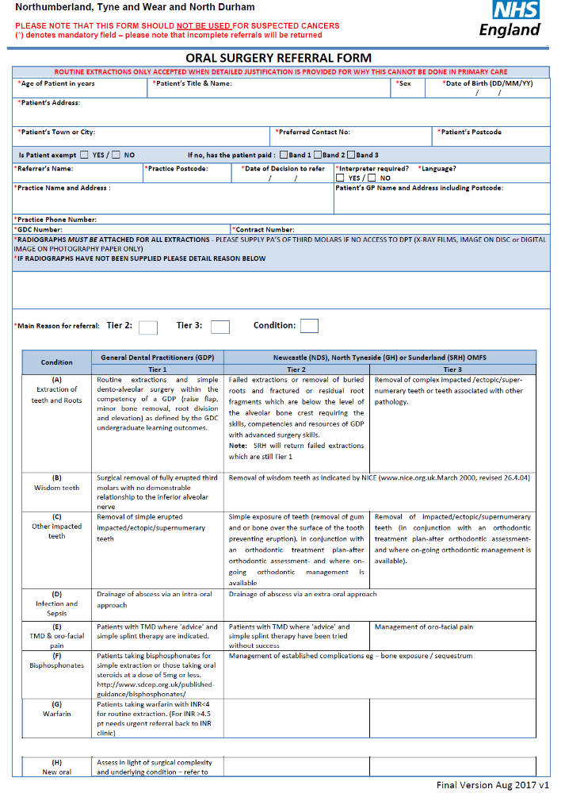
Appendix E
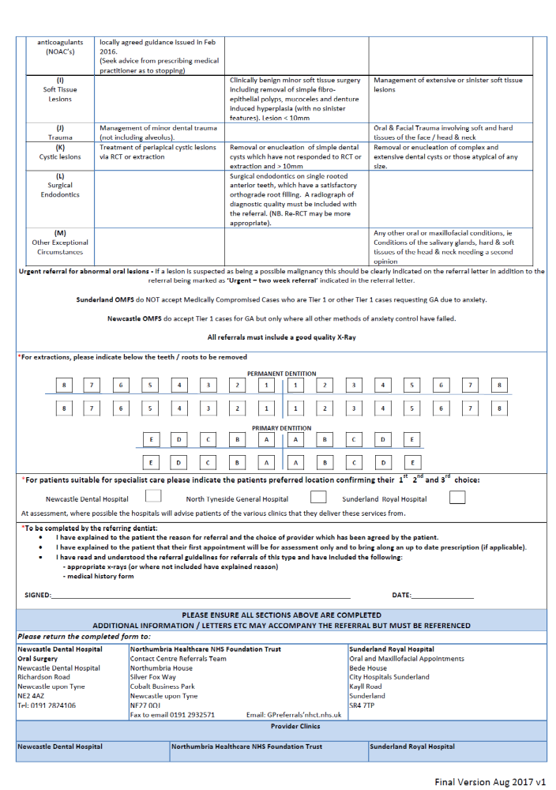

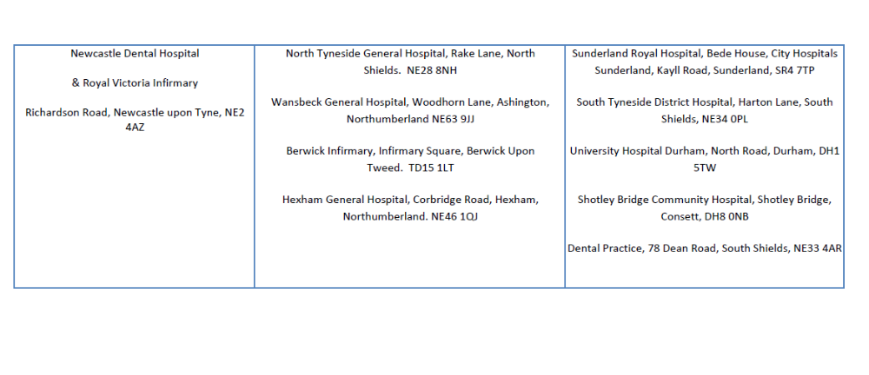
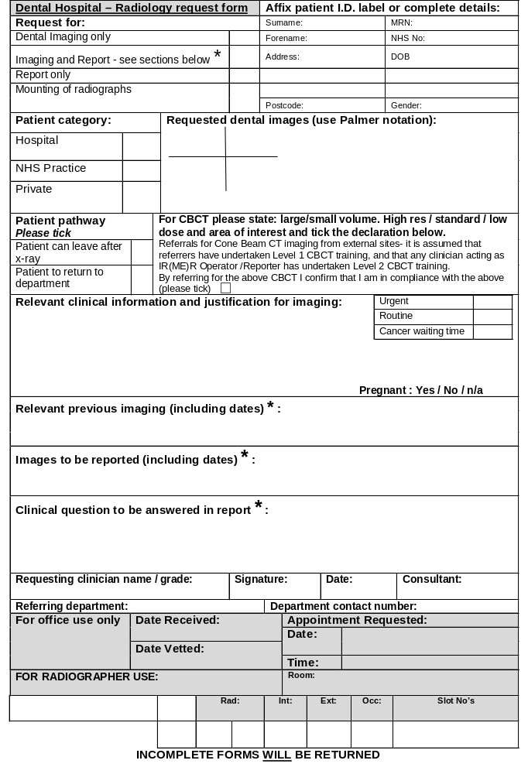
Appendix F – Radiology referral form
This form can be emailed to nuthdentalradiology@nhs.net

